SENIOR FIVE TERM 2
TOPIC 1/3: Periodicity 1
Topic competency: The learner analyses the trends and periodic properties of elements, to explain and predict the reactivity and properties of elements in the Periodic Table.

The Periodic Table (PT)
The Periodic Table is a tabular arrangement such that vertical columns contain elements with electronically similar atoms. The horizontal rows of the Periodic Table are called periods while the vertical columns are called groups. There are 7 periods and 8 groups.

Some special groups

Group I (1A)
This consists of the elements, H, Li, Na, K, Rb, Cs, and Fr; except hydrogen, these elements are highly metallic in character and are known as alkali metals.

Group II (2A)
This consists of the elements, Be, Mg, Ca, Sr, Ba and Ra. All these elements are metals but their metallic character is less than that of group 1. These elements are known as alkaline earth metals.

Group VII (7B)
This consists of elements, F, Cl, Br, I and At. All these elements are nonmetals and are known as halogens.

Group VIII (0)
Consist of the elements, He, Ne, Ar, Kr, Xe and Rn. These elements are non-reactive and are known as the noble elements or inert elements or zero element and are all gaseous elements at room temperature.

Summary
The extreme left of the Periodic Table consists of metals with exception of hydrogen; the extreme right end consists of non-metals. The middle part of Periodic Table consists of semi-metals or metalloid.

  meta |  |  |  |   metals
 | ls |  | non
 | ls |   metalloids | non

Fig. 4.1. Simplified PT to show the variation of properties
Therefore, the metallic characters of the elements decrease across the period, i.e., (left - right).

The periodic table commonly used by Uganda National Examinations Board is given in figure 4.2;
1 | 2 |  |  |  |  |  |  |  |  |  |  | 3 | 4 | 5 | 6 | 7 | 8
1.0  H  1 |  |  |  |  |  |  |  |  |  |  |  |  |  |  |  | 1.0  H  1 | 4.0  He  2
6.9  Li  3 | 9.0  Be  4 |  |  |  |  |  |  |  |  |  |  | 10.8  B  5 | 12.0  C  6 | 14.0  N  7 | 16.0  O  8 | 19.0  F  9 | 20.2  Ne  10
23.0  Na  11 | 24.3  Mg  12 |  |  |  |  |  |  |  |  |  |  | 27.0  Al  13 | 28.1  Si  14 | 31.0  P  15 | 32.1  S  16 | 35.4  Cl  17 | 40.0  Ar  18
39.1  K  19 | 40.1  Ca  20 | 45.0  Sc  21 | 47.9  Ti  22 | 50.9  V  23 | 52.0  Cr  24 | 54.9  Mn  25 | 55.8  Fe  26 | 58.9  Co  27 | 58.7  Ni  28 | 63.5  Cu  29 | 65.7  Zn  30 | 69.7  Ga  31 | 72.6  Ge  32 | 74.9  As  33 | 79.0  Se  34 | 79.9  Br  35 | 83.8  Kr  36
85.5  Rb  37 | 87.6  Sr  38 | 88.9  Y  39 | 91.2  Zr  40 | 92.9  Nb  41 | 95.9  Mo  42 | 98.9  Tc  43 | 101  Ru  44 | 103  Rh  45 | 106  Pd  46 | 108  Ag  47 | 112  Cd  48 | 115  In  49 | 119  Sn  50 | 122  Sb  51 | 128  Te  52 | 127  I  53 | 131  Xe  54
133  Cs  55 | 137  Ba  56 | 139  La  57 | 178  Hf  72 | 181  Ta  73 | 184  W  74 | 186  Re  75 | 190  Os  76 | 192  Ir  77 | 195  Pt  78 | 197  Au  79 | 201  Hg  80 | 207  Ti  81 | 207  Pb  82 | 209  Bi  83 | 209  Po  84 | 210  At  85 | 222  Rn  86
223  Fr  87 | 226  Ra  88 | 227  Ac  89
 |  |  | 139  La  57 | 140  Ce  58 | 141  Pr  59 | 144  Nd  60 | 147  Pm  61 | 150  Sm  62 | 152  Eu  63 | 157  Gd  64 | 159  Tb  65 | 162  Dy  66 | 165  Ho  67 | 167  Er  68 | 169  Tm  69 | 173  Yb  70 | 175  Lu  71
 |  |  | 227  AC  89 | 232  Th  90 | 231  Pa  91 | 238  U  92 | 237  Np  93 | 244  Pu  94 | 243  Am  95 | 247  Cm  96 | 247  Bk  97 | 251  Cf  98 | 254  Es  99 | 257  Fm  100 | 256  Md  101 | 254  No  102 | 260  Lw  103

Fig. 4.2 Periodic Table commonly used by Ugand National Examinations Board

Trends in physical properties of elements in the periodic table The physical properties to be considered will include:
- Electronegativity/Electropostivity.
- Metallic character.
- Atomic sizes/atomic radius.
- Ionic size/ionic radius.
- Ionization energy.
- Electron affinity.
- Melting points/boiling points.

Electronegativity
In a covalent bond between unlike atoms the shared pair of electrons will not be shared equally, because the atom with a greater attraction to electrons will pull the shared electron toward itself. Electronegativity is the measure of an atom's ability to attract shared electrons in a chemical bond
The electronegativity of elements increases across each period, e.g.

Table 4.1 Variation of electronegativity across the second period of the Periodic Table
Elements of 2nd period: Li Be B C N O F
Electronegativity (arbituary units): 1.0 1.5 2.0 2.5 3.0 3.5 4.0

NB: Fluorine, the most electronegative elements, is given an arbitrary value of 4 and the electronegativity of the atoms of other elements is related to it.

Reasons
Across a period, electronegativity increases because atomic size decrease while the nuclear charge increase thus pulling the electrons more strongly, table 4.1
Down a group, electronegativity decreases because atomic size and screening effects increase, the valence electrons become increasing far from the nucleus and hence experience less attraction, table 4.2.

Table 4.2 Variation of electronegativity down group 1 of the Periodic Table

Elements of group 1A: Li Na K Rb Cs
Electronegativity (arbituary units): 1.0 0.9 0.8 0.8 0.7

Factors affecting electronegativity
- Atomic size: Electronegativity decreases as atomic size increases. Larger atoms have valence electrons farther from the nucleus, weakening the attraction for shared electrons.
- Nuclear charge: A higher nuclear charge (more protons) increases electronegativity because it creates a stronger positive pull on electrons.
- Shielding effect: This is the reduction of the nuclear pull on valence electrons due to inner-shell electrons. A greater shielding effect leads to lower electronegativity.
- Oxidation state: Atoms with higher oxidation states have greater electronegativity. The increased positive charge on the atom pulls electrons more strongly.
- Electronic configuration: Atoms that are closer to a stable noble gas configuration, like those with nearly filled valence shells, have higher electronegativity.
- Hybridization: The s-character in an atom's hybrid orbital affects its electronegativity. Orbitals with more s-character (e.g., sp>sp2>sp3 s) are closer to the nucleus, resulting in higher electronegativity.

Trial 4.1
- Explain what is meant by the term electronegativity
State the factors that determine the value of electronegativity of an element
- Explain how the following factors affect the value of electronegativity of an element
  - atomic radius,
  - nuclear charge,
  - the screening effect of the inner electrons

Electropositivity
This is the measure of the ease of an atom of an element to lose valence electrons.
Across the period, electropositivity decreases due to an increase in the effective nuclear attraction on the valence electrons shells.
Down the group, electropositivity increases due to the decrease in effective nuclear attraction on the valence electrons as the atomic sizes and screening effect increase. Thus, group IA elements are the most electropositive elements.

Trial 4.2
Explain the variations in the electropositivity of the following elements
- C, Ge and Sn
- Mg, Al, P and Cl (8marks)

Metallic character
Metallic character refers to how readily an element can lose electrons to form positive ions (cations).

Periodic Trends
Across a period (left → right): Metallic character decreases.
Reason: Ionization energy increases and atoms hold onto electrons more tightly.
Example: Sodium (Na, metallic) → Aluminum (Al, less metallic) → Silicon (Si, metalloid).
Down a group (top → bottom): Metallic character increases.
Reason: Atomic size increases, ionization energy decreases, so electrons are lost more easily.
Example: Lithium (Li, less metallic) → Cesium (Cs, highly metallic).

Atomic radii
Atomic radius is the distance between the center of the nucleus and furthest electron under the influence of a nuclear charge of an atom. Or Atomic radius is the distance from the nucleus of an atom to the outermost electron shell.

Periodic Trends
Across a period (left → right): Atomic radius decreases.
Reason: Nuclear charge increases, pulling electrons closer, while shielding remains nearly constant.
Example: Na > Mg > Al > Si > P > S > Cl.
Down a group (top → bottom):Atomic radius increases.
Reason: New electron shells are added, increasing distance from the nucleus despite higher nuclear charge.
Example: F < Cl < Br < I.

Variation of atomic radii in transition elements
From Sc to Mn: Atomic radii decrease gradually.
Reason: Increasing nuclear charge pulls electrons closer to the nucleus while shielding is minimal because d-electrons are not very effective at screening.
From Fe to Cu: Atomic radii remain almost constant.
Reason: Added d-electrons provide significant shielding, counteracting the increased nuclear charge. The attraction between the nucleus and outer 4s electrons is reduced.
At Zn (end of series): Atomic radius shows a slight increase.
Reason: Fully filled d-orbitals (3d¹⁰) shield the 4s electrons strongly, reducing nuclear pull.

Trial 4.3
- (a) Explain what is meant by atomic radius (4marks)
  - Describe and discuss the change in radii in the following series
    - Na, Mg, Al, Si, P, S and Cl (7 marks)
    - F, Cl, Br and I (4 marks)
    - Ti, V, Cr, Fe, Co (4 marks)
- (a) What is meant by the term ‘atomic radius’? (4marks)
  - Explain how atomic radii vary
    - Along a short period of a Periodic Table
    - Down the group in the periodic table (8marks)
- The atomic number and atomic radii of some transition metals are given in the table below
Element  Atomic number  Atomic radii (Å) | Sc  21  1.44 | Ti  22  1.32 | V  23  1.22 | Cr  24  1.17 | Mn  25  1.17 | Fe  26  1.16 | Co  27  1.16 | Ni  28  1.15 | Cu  29  1.17 | Zn  30  1.25
    - Plot a graph of atomic radii versus atomic atomic number (4marks)
    - Explain the shape of your graph (7marks) Ionic radii
The variation of the ionic radii across the period and down the groups is similar to those of the atomic radii as demonstrated by examples in table 4.5 and 4.6 respectively.

Table 4.5 Variation of ionic radii across the second period of the Periodic Table
Ions Li⁺ Be²⁺ B³⁺ O²⁻ F⁻
Ionic radius(nm) x10 0.78 0.31 0.20 1.40 1.36

Table 4.6 Variation of ionic radii down group 1 of the Periodic Table
Ions Li⁺ Na⁺ K⁺ Rb⁺ Cs⁺
Radii (nm) x 10 0.060 0.095 0.133 0.148 0.165

NB: (a) Atomic radii are very much smaller than anionic radii but very much larger than cationic radii (table 4.8).

Table 4.7 Comparison atomic and ionic radii of cation and anion
Atoms | ions
Na 0.157nm | Na⁺ 0.095 nm (cation)
Cl 0.099n m | Cl⁻ 0.181 nm (anion)

(b) The radii of iso-electronic positive ions, (i.e., ions with the same number of electrons, e.g. both Li⁺ and Be²⁺ have the number of electron), decrease with increasing positive charge. There is only a small change in ionic radii for iso-electronic negative ions with a change in negative charge e.g. Cl⁻ and S²⁻ in table 2.10

Table 4.8 Comparison of ionic radii of iso-electronic ions

Li⁺ 0.060nm S²⁻ 0.184nm
Be²⁺ 0.031nm Cl⁻ 0.181nm

Trial 4.4
- Explain how the sizes of ionic radii of group II ions affect the properties of their compounds compared to those formed by group I metals (8marks)
- Explain the following observation
  - In going from sodium (0.189nm) to chlorine (0.099nm) along period of the periodic table, there is steady decrease in the size of covalent radii.
  - Although K⁺ and Cl⁻ ion both have 18 electrons the ionic radius of K⁺(0.132nm) while that of Cl⁻ is (0.181nm)

Variation ionic radii of transition metals
- Since the transition metals show many oxidation states, the ionic radii of the ions of different oxidation states are different.
- Generally, the ionic radii of different cations of the same element in different oxidation state decrease with the increase in oxidation state, e.g. Cr2+>Cr3+>Cr4+>Cr5+>Cr6+
This is due to increase in effective nuclear charge.
- Ionic radii of cations of different elements in the same oxidation state generally decrease with the increase in nuclear charge or atomic number e.g. Fe2+>Co2+>Ni2+>Cu2+

Ionization energy (I.E)
This is the energy required to remove one electron in the ground state completely from a gaseous atom or ion. The ionization energy thus, may be classified as first, second, third ionization energy, etc.
A(g) A⁺(g) + e ΔH = 1st I.E
A⁺(g) A²⁺(g) + e ΔH = 2nd I.E
A²⁺(g) A³⁺(g) + e ΔH = 3rd I.E

Variation of the first ionization energy across the period
The first ionization energies of the first 20 elements of the PT. plotted against their atomic number are shown in Fig.4.2 below:
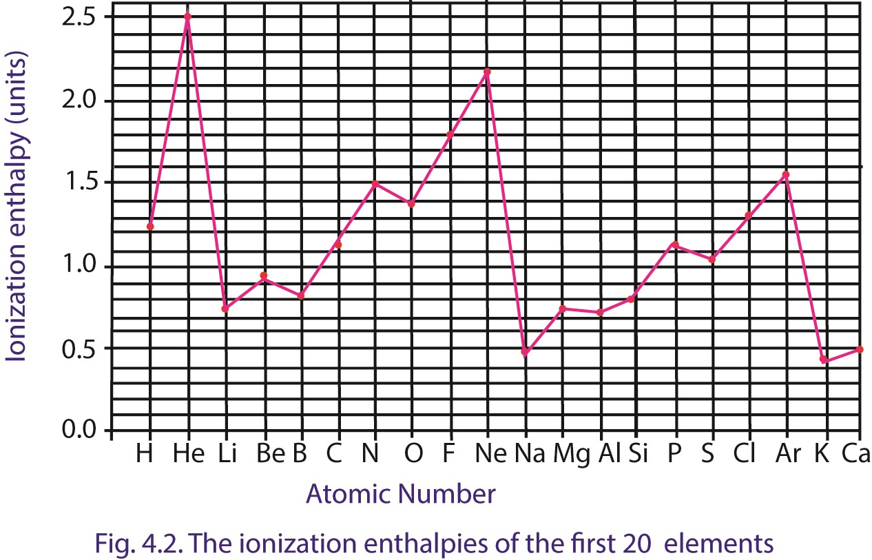
From lithium to neon there is a pronounced increase in ionization energy with slight breaks occurring at positions occupied by boron and oxygen. An exactly similar trend occurs in the portion of the graph from sodium to argon.

Reason for two trends
- The increase in the first ionization energy across the period is due to increase in the effective nuclear charge on the valence electron as the number of electrons on the outer shell increases.

- Half filled (ns¹, np³ nd⁵) or completely filled (ns²np⁶nd¹⁰) orbital are comparatively more stable and hence more energy is needed to remove an electron from them. This explains why the first ionization energy of beryllium (full orbital, 1s² 2s²) and nitrogen (half full orbital, 1s² 2s² 2p³) are higher than that of boron and oxygen respectively.

- The sharp decrease in ionization energy from helium to lithium is explained by the fact that the outer electron in lithium is far from the nucleus than in helium. Also the removal of an electron from helium leads to a less stable half full orbital while removal of an electron from lithium leads to formation of a stable full orbital 1s².

Variation of the first ionization energy down a group
For elements in the same group, the ionization energies decrease down the group, due to increase in the screening effect or decrease in the effective nuclear charge because electros are added to a new shell. For example the first ionization energy of lithium, sodium and potassium are 520, 494, and 418kJmol⁻¹ respectively.

Trial 4.5
- the graph of first ionization energy against atomic number for the elements in the third short period of the Periodic Table is shown below
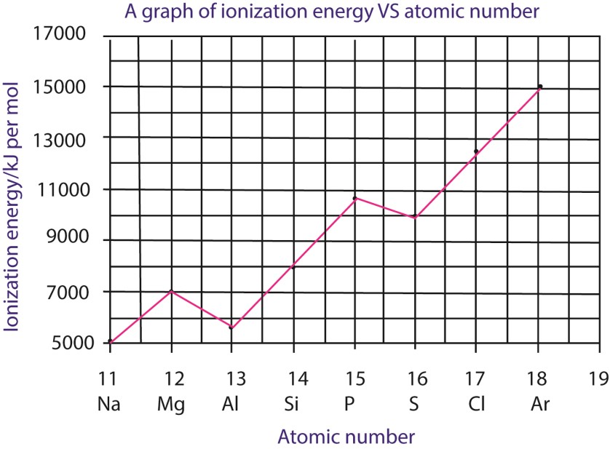

  - What is meant by first ionization energy? Illustrate your answer using the sodium atom. (3 marks)
  - Explain the general trend in the first ionization energy of the elements shown in the graph
(3marks)
  - The first ionization energies of Al and S are lower than expected. explain (5marks)
- Describe the trend in the first ionization energy down group I of the periodic Table and explain your
answer (5marks)
- Show how the first ionization energies of the elements in a group are related to their reactivity. Illustrate your answer using the reaction of group I elements with water (4marks)

Trial 4.5
- Define the term ionization energy
- The first ionization energies of element in period III of the periodic Table and atomic numbers are given in the table below
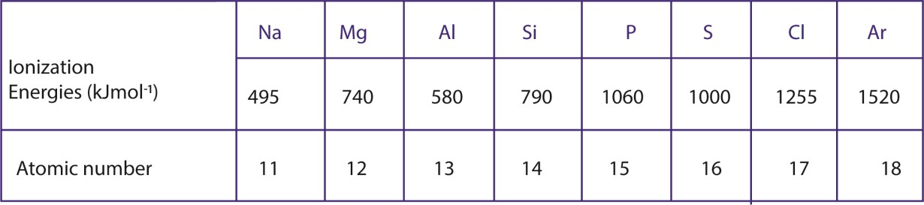
Plot a graph of ionization energy against atomic number and explain the shape of the graph (9 marks)
- The melting points of magnesium, silicon and Sulphur are 650⁰C, 1423⁰C and 120⁰C respectively. Explain the difference in melting points of the elements (6 marks)
- (i) Name the type of bonding that exist in the hydrides of Na, P and S (1½ marks)
- Write equation to show the reaction, if any, of hydride in (i) with water (2½ marks)

Trial 4.6
The graph in figure 2 shows the variation of the first ionization energies of the elements in the first row of the periodic Tables
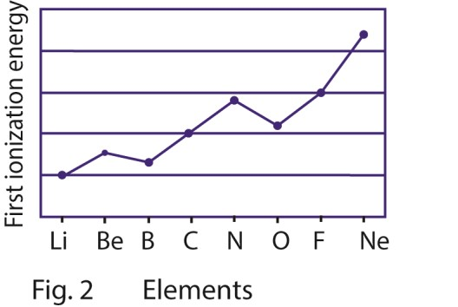

Explain the following observations
(i) there is a general increase in first ionization energy from lithium to neon (3marks) (ii) The first ionization energy of beryllium is higher than that of boron.
(iii) The first ionization energy of oxygen is lower than that of nitrogen.

Variation of successive Ionization energy of an atom
Very convincing evidence for arrangement of electrons into definite shells is available from tabulated values of successive ionization energies of atoms; those for the potassium atom are shown in figure 4.3. The ionization energies cover a very wide range of values and for the convenience of graphical plotting of their logarithmic values are used.
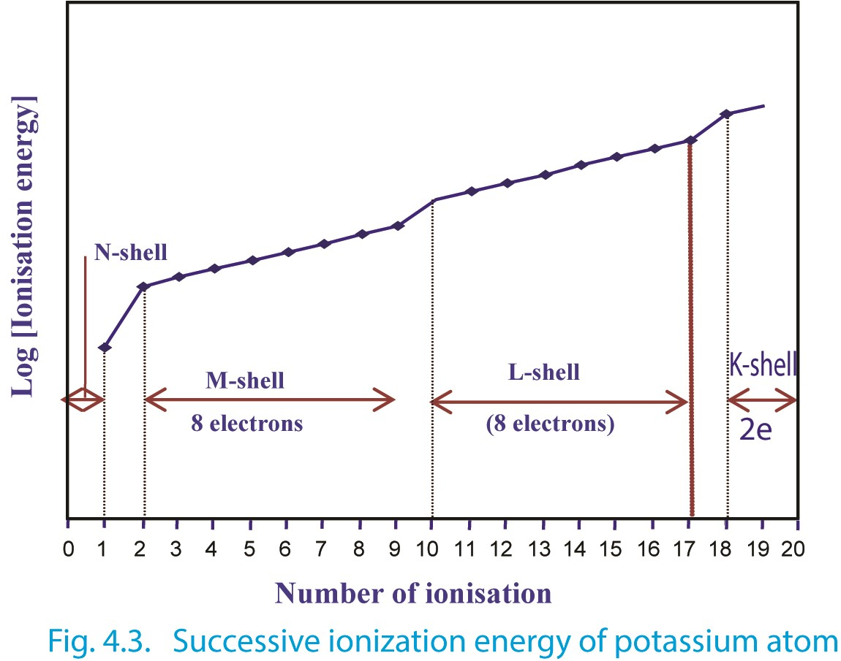

The clear-cut increases in ionization energy are observed when the 2nd, 10th and 18th electrons are involved, which indicate quite clearly that the nucleus of the potassium atom is surrounded by electron grouped into a number of shells. Successive ionization of electrons becomes difficult, since every time an electron is removed; the atom carries one more unit of positive charge.
However, the large increases in ionization energy for removal of the second 2nd, 10th and 18th electrons suggest that the 2nd electron is closer to the nucleus than the 1st electron; similarly the 10th and 18th electrons are nearer to the nucleus than the 9th and 17th electrons respectively. Thus, electrons of a potassium atom can be grouped into shells as follows:

Table 4.9 Arrangement of electrons in potassium atom

K L M N
SHELL

2 8 8 1
NUCLEUS 19p, 20n

The electronic configuration of potassium is thus, written as 1s² 2s² 2p⁶ 3s² 3p⁶ 4s¹.
The properties of elements are closely linked to their ionization energies. The magnitude of the ionization energy is the measure of metallic character of the elements. The first ionization energies for metals are nearly all below 800kJ/mol whereas those of non-metal are nearly all above 2000kJmol⁻¹.

Trial 4.7
- Explain the following observation
  - Although ionization energy generally increase across a period in the periodic table, the ionization energy of boron is less than that of beryllium (5marks)
  - Both valence electron of magnesium occupy the same energy levels yet the second ionization energy of magnesium is greater than its ionization energy (3marks)
  - Calcium forms compound containing Ca²⁺ ions, but none containing Ca⁺ even though its first ionization energy is lower than the second ionization energy.

- (a) The first ionization energies of aluminium are 577, 1816, 2745, 11573kJ mol⁻¹.
Explain the trend in ionization energy. (3marks)
(b) Aluminium forms stable compound in which aluminium has an oxidation state of +3 but not +2 or +1. Explain this observation.

- (a) Write electronic configuration of strontium(1mark)
  - What is the principal oxidation state of strontium? (1mark)
  - State whether the first ionization energy of strontium is greater or less than of barium. Explain your answers
- The diagram below shows successive ionization energies for an element X, showing removal
all electrons
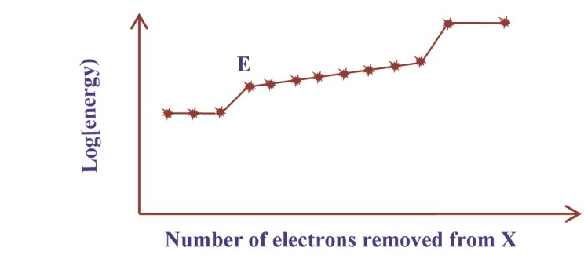
  - Giving reasons state
      - The group of element X
      - The period of element X
      - Identify element X (4marks)
  - Explain the sudden increase in the energy required to remove electron E (2marks)
  - Explain how the size of X will change as electrons are removed (1marks)

- (a) the first eight ionization energies of an element B are shown below Ionization Energies/kJmol⁻¹
1st | 2nd | 3rd | 4th | 5th | 6th | 7th | 8th
786 | 1580 | 3230 | 4360 | 16000 | 20000 | 23600 | 29100
  - Explain what is meant by the term first ionization energy?
  - State the factors that determine the value of the first ionization energy and explain how they affect this values
  - To which group in the periodic table does element B belong explain your answer

- The table below shows the ionization energies (in kJmole-1) of five elements lettered A, B, C, D and E
Elements | 1st | 2nd | 3rd | 4th
A  B C  D  E | 500  740  630  900  580 | 4600  1500  1600  1800  1800 | 6900  7700  3000  14800  2700 | 9500  10500  4800  21000  11600
  - Which one of these elements is most likely to form an ion with a charge of +1? Give reason for your answer
  - State
    - Two elements which belong to the same group in the periodic table
    - The group to which you have stated in (b)(i) belong
  - (i) write the formula of chloride of element E
(ii) Write equation for the reaction between the chloride of element E and water.
- Explain the following
  - The atomic radius decrease with the increasing atomic number in a period
  - Na-atom is larger than both Li and Mg
  - The second ionization energy is always higher than the first
  - The first ionization of Be is higher than that of B

Electron affinity
This is the energy involved in adding an electron to a gaseous atom. It is the energy change for the process.
A (g) + e⁻ → A⁻ (g) ΔH = electron affinity.

Electron affinities of elements increase across a period due to increase in the effective nuclear charge (or electronegativity) and decreases down a group due to the decrease in the effective nuclear charge on the valence shell. Halogens have the highest values of electron affinities. However, the electron affinity of fluorine is lower than that of chlorine. This is due to the fact that the size of fluorine atoms is small, thus the incoming electron is repelled by the nine electrons that are close to each other in the valence shell.
The successive electron affinities become more and more endothermic because the incoming electron is repelled by the electrons already in an atom; therefore, additional energy is required to add this electron.

Trial 4.8
- Explain the difference between electronegativity and electron affinity
- The first electron affinity of group VII elements are given in table below
Element | F | Cl | Br | I
1st electron affinity kJmol⁻¹ | -328 | -349 | -325 | -295
  - Explain what is meant by the term electron affinity
  - Explain the trend in the first ionization energy
  - The first and second electron affinity values for oxygen atom are -121kJmol⁻¹ and +744kJmol⁻¹ respectively. Explain why the second electron affinity is endothermic.

Melting points of elements
The melting point of a substance or element is the measure of energy required to break down the regular arrangement of atoms, ions or molecules in the crystal (solid state). Therefore, the melting point indicates the strength of the forces knitting atoms, ions or molecules together in the crystal. The strength of those forces in elements varies according to the type of crystals formed and due to this; the melting points of elements in period do not change uniformly, (e.g table 4.10).
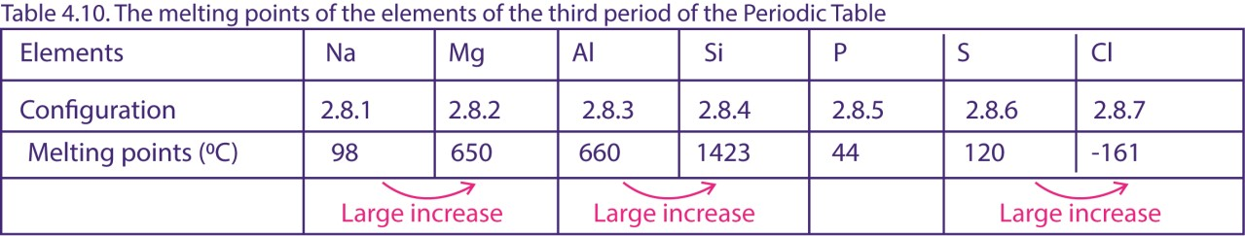
From sodium to aluminium, the melting point increase due to increase in the strength of metallic bonds. The strength of metallic bonds increase as the number of electrons contributed to form the metallic bond increase. Sodium contains one loosely bound electron in the valence shell, and this electron is readily contributed to the formation of the metallic bond. Magnesium contains two electrons in the valence shell and both electrons are contributed to the formation of a metallic bond.
The metallic bond in magnesium is thus stronger than that in sodium, which explains the large difference in the melting points.
However, the increase in melting points from Mg to Al is not as sharp as expected, probably because only two electrons of aluminum are used in formation of the metallic bond.
Silicon has the highest melting point because it uses its four valence electrons to form an infinite three-dimensional assembly of atoms linked by a single covalent bond; thus, high temperatures are required to break these strong bonds.


In the structure, each silicon atom is tetrahedrally bonded to four silicon atoms with a crystal unit of five silicon atoms (ABCDE) in figure 4.11 (the structure similar to that of diamond). Such a structure is described as a three-dimensional giant structure. As the melting of silicon involves breaking of the strong covalent bonds, the melting point of silicon is thus very high.

-
Silicon

atom

D

B

A

C

E

Fig. 4.11 Structure of silicon
The melting point of P, S, Cl is dependent on the size/mass of the molecules formed. The melting points of phosphorus and sulphur are relatively higher than expected because they exist as P₄ and S₈, rather than simples individual atoms; thus, the intermolecular forces are stronger. The boiling point of chlorine is very low because it exists as discrete diatomic molecule, Cl₂ held together by weak van der Waals forces.

Trial 4.8
The atomic numbers and the melting points of some elements in period 3 of the Periodic Table are shown below
Element | Na | Mg | Al | Si | P
Atomic number | 11 | 12 | 13 | 14 | 15
Melting points/⁰C | 98 | 650 | 660 | 1410 | 44
- (i) Plot a graph of melting points against atomic number (3 marks)
(ii) Explain the shape of the graph in (i) (6marks)

- Describe and explain how the oxides of magnesium, aluminium and silicon react with
  - sodium hydroxide
  - hydrochloric acid (9marks)
- state the type of bonding in the oxides of sodium and phosphorus
(2marks)

Chemistry of period 3 elements
The chapter compares the chemistry of elements in the same period specifically period 3. Each element in a period provides a representative chemistry of the group into which it exists.
The elements of period 3 are Na, Mg, Al, Si, P, S, Cl.
Electronic structure
For each of these elements the total number of electrons in the outer most shell is equal to the group in which it exists.

Table 4.11. The electron configuration of period 3 elements
Elements | Na Mg Al Si P S Cl Ar
valence configuration | 3s¹ 3s² 3s²3p¹ 3s²3p² 3s²3p3 3s²3p⁴ 3s²3p5 3s²3p⁶

Reactions of the period elements

Reaction period 3 elements with water
Reactivity with water decreases across the period because there is a decrease in electropositivity of these elements across the period.
i) Sodium reacts vigorously with cold water. 2Na (s) + 2H₂O (l) → 2NaOH (aq) + H₂ (g) ii) Mg does not react with cold water but with steam to form oxide Mg (s) + 2H₂O (g) → MgO (aq) + H₂ (g) iii) Al react very slowly to form hydroxides: 2Al (s) + 6H₂O (l) → 2Al(OH)₃ (s) + 3H₂ (g) iv) Si, P, S have no reaction with water.
v) Chlorine reacts with water to form chloric (I) acid and HCl.
Cl₂ (g) + H₂O (l) → HOCl (aq) + HCl (aq)

Reaction period 3 elements with NaOH
- Aluminium reacts with aqueous NaOH to produce hydrogen and a complex salt -sodium aluminate.
2Al (s) + 2NaOH (aq) + 6H₂O (l) → 2NaAl(OH)₄ (aq) + 3H₂ (g)
Or Al (s) + 2OH⁻ (aq) → AlO²⁻(aq) + H₂(g)
This is because aluminium is amphoteric, i.e., possesses both metallic and nonmetallic properties.
- Chlorine reacts to form sodium chlorate (I), sodium chloride and water.

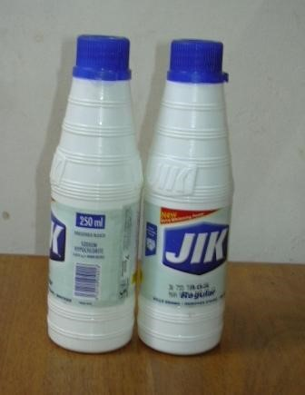
Cl₂ (g) + 2NaOH (aq) → NaOCl (aq) + NaCl (aq) + H₂O (l)

Sodium hypoochlorate (I) is used as a bleaching and antiseptic agent such as Jik (Fig. 6.1)

- Phosphorus reacts with hot concentrated NaOH to produce Phosphine

P₄ (s) + 3⁻OH (aq) + 3H₂O (l) → PH₃ (g) + 3H₂PO₂⁻ (aq)

- Na, Mg, Si, S have no reaction.

Fig.4.12 sodium chlorate 1 is used in Jik
a house hold household detergent

Reaction of period 3 element with HCl
Reactivity decreases across the period due to decrease in metallic properties.
i) Na, Mg, Al react to form H₂ and metal salts. 2Na (s) + 2HCl (aq) → 2NaCl (aq) + H₂ (g)
Mg (s) + 2HCl (aq) → MgCl₂ (aq) + H₂ (g) 2Al (s) + 6HCl (aq) → 2AlCl₃ (aq) + 3H₂ (g) ii) Si, P, S, Cl have no reaction.

Oxides of period 3 elements

Table 4.12: The oxide of Period 3 elements
LEMENTS | Na | Mg | Al | Si | P | S | Cl
OXIDES | Na₂O | MgO | Al₂O₃ | SiO₂ | P2O5 | SO₃ | Cl₃O₇
PRINCIPAL  BONDING | Ionic | Ionic | Ioniccovalent | Covalent | Covalent | Covalent | Covalent
CHARACTER | Basic | Basic | Amphoteric | Acidic | Acidic | Acidic | Acidic
MP\⁰C | 1193 | 3075 | 2300 | 1728 | 563 | 30 | -91

Trial 4.9
- Complete the table below (4 ½ marks)
Element | Formula of oxides | Type of oxide | bonding | in | Structures of oxide
Al
Si
P
- Write an equation for the reaction between the oxide of aluminium and sodium hydroxide (1½)

Physical properties of oxides of period 3 elements
- Across the period there is a gradual charge in character of oxides from strongly basic to strongly acidic. Al₂O₃ is amphoteric oxide, i.e., possesses both basic and acid properties.

- Na₂O, MgO and Al₂O₃ have high melting points due to the strength of ionic bonding. SiO₂, although covalent has high melting point because the crystal of SiO₂ is a giant structure in which silicon atoms and oxygen atoms are bonded together by a single strong covalent bonds.
P₂O₅ (white solid) consists of P₄O₁₀ molecules; these contain electric dipoles due to electron displacements in their bonds and are quite strongly attracted to each other. This is why its melting point is high compared with that of SO₃ which consists of simple SO₃ molecules.
Cl₂O₇ has a low melting point because the molecules are held together by the weak van der Waals forces.

Reactions of oxides of period 3 elements

Reaction oxides of period 3 elements with water
- Na₂O and MgO react with water to form hydroxides.
Na₂O (s) + H₂O (l) → 2NaOH (aq)
- Al₂O₂ has no reaction with water because it is an insoluble oxide.
- SiO₂ has no reaction with water.
- P₂O₅, SO₂, Cl₂O₇ are acid anhydrides, i.e., react with water to form acid.
P₂O₅ (s) + H₂O (l) → 2HPO_{3,} phosphoric acid
Then, HPO₃ + H₂O → H₃PO₄ phosphoric
SO₃ (s) + H₂O (l) → H₂SO₄ (aq), sulphuric
Cl₂O₇ (g) + H₂O (l) → 2HClO₄(aq), perchloric acid

Reaction period 3 elements with NaOH
- Na₂O, MgO are basic, therefore, have no reaction with water.
- Al₂O₃ being amphoteric reacts with dilute NaOH to produce sodium aluminate and water.
Al₂O₃ (g) + 2NaOH (aq) → 2NaAlO₂ (aq) + H₂O (l)
- SiO₂ reacts to form sodium silicate and water.
SiO₂ (s) + 2NaOH (aq) → Na₂SiO₃ (aq) + H₂O (l)
- P₂O₅, SO₃ and Cl₂O₇ react to form salts and water
SO₃ (g) + 2NaOH (aq) → Na₂SO₄ (aq) + H₂O (l)
P₂O₅ (s) + 2NaOH (aq) → 2NaPO₃ (aq) + H₂O (l)
Cl₂O₇ (g) + 2NaOH (aq) → 2NaClO₄ (aq) + H₂O (l)

Trial 4.10
Write an ionic equation for the reaction between sodium hydroxide and (1 ½ mark each)
- Silicon (IV) oxide
- Lead (II) oxide
- Aluminium oxide

Chlorides of period 3 elements

Table 4.13: The chlorides of period 3 elements
ELEMENTS | Na | Mg | Al | Si | P | S | Cl
CHLORIDES | NaCl | MgCl₂ | AlCl₃ | SiCl₄ | PCl₅ | S₂Cl₂ | Cl₂
BONDING | Ionic | Ionic | Covalent | Covalent | Covalent | Covalent | Covalent
STATES | Solid | Solid | Solid | Liquid | Solid | Liquid | Gas
MP\⁰C | 808 | 714 | 192 | -68 | 160 | -76

Physical properties of period 3 chlorides
NaCl and MgCl₂ have high melting points due to the strength of the ionic bonding. AlCl₃ has fairly high melting point because in the solid state, it consists of Al₂Cl₆ molecules and not AlCl₃. These molecules are produced through dative bonding between Al and Cl in the Al₂Cl₆ molecules.
Al
Al
Cl
Cl
Cl
Cl
Cl
Cl
SiCl₄ and S₂Cl₂ are liquid and consist of respective simple SiCl₄ and S₂Cl₂ molecules and in the solid state the molecules are held by weak van der Waals’ forces that explains their very low melting points. PCl₅ a pale yellow solid has a fairly high melting point because the solid undergoes partial ionization.
2PCl₅ PCl₄⁺ + PCl₆⁻

Trial 4.11
Explain the following observations:
(a) Sodium chloride melts at 800⁰C whereas aluminium chloride sublimes at 180⁰C. (3marks)

Reactions of chlorides of period 3 element

Reactions of chlorides of period 3 element with water.
- NaCl and MgCl₂ have no reaction with water but simply dissociate into ions.
NaCl (s) + (aq) → Na⁺ (aq) + Cl⁻ (aq)
MgCl₂ (s) + (aq) → Mg²⁺ (aq) + 2Cl⁻ (aq)

- AlCl₃, SiCl₄, PCl₅, Cl₂ are hydrolyzed by water. However, the extent of the hydrolysis of these chlorides varies across the period.
AlCl₃ is slightly hydrolyzed liberating HCl and Al(OH)₃.
AlCl₃ (s) + 3H₂O (l) → Al(OH)₃(s) + 3HCl (aq)
However, when aluminium chloride is added to water, it reacts exothermically to give hydrated aluminium ions, [ Al (H₂O)₆]³⁺ and chloride ions, Cl⁻. The energy needed to break the Al-Cl covalent bond is derived from the high enthalpy of hydration of small highly charged Al³⁺ ions.

Al₂Cl₆ (s) + 12 H₂O (l) → 2[Al(H₂O)₆]³⁺(Cl⁻)₃
covalent ionic

Hydrated aluminium chloride is readily soluble in water yielding [Al(H₂O)₆]³⁺ (aq) + 3Cl⁻ (aq) ions

PCl₅ (s) + 4H₂O (l) → 5HCl (aq) + H₃PO₄ (aq) [phosphoric acid]
SiCl₄, PCl₅, and S₂Cl₂ are completely hydrolyzed liberating hydrogen chloride.
SiCl₄ (l) + 3H₂O (l) → 4HCl (aq) + H₂SiO₃ (aq) [silicic (IV) acid]
2S₂Cl₂ + 3H₂O (l) → 4HCl (aq) + H₂SO₃ (aq) + 3S (s)
Hydrogen chloride under moist conditions appears as white fumes because these chlorides fume in moist air, their hydrolysis leads to formation of HCl. The hydrolysis of each of these chlorides occurs in stages. As an example, lets us consider the hydrolysis of SiCl₄.

Trial 4.12
The melting points of the chlorides of some elements are given below.
chlorides | MgCl₂ | FeCl₃ | PCl₅
Mp/⁰C | 712 | 282 | -112
Type bonding
- State the type of bonding that exists in each of the chloride in the table above.
- State what would be observed and write an equation for the reaction that takes place when water is added to each of the chloride in table above. (2½ marks each)

The hydrides of period 3 elements
The hydrides formed by period 3 elements are NaH, MgH₂, AlH₃, SiH₄, PH₃, H₂S, HCl. Table 4.14: The properties of period 3 hydrides
ELEMENTS | NaH | MgH₂ | AlH₃ | SiH₄ | PH₃ | H₂S | HCl
BONDING | Ionic | Ionic | ionic | Covalent | Covalent | Covalent | Covalent
MP\⁰C | 804 |  |  |  | -134 | -86 | -144
bp\0C | 1413 |  |  |  | -88 | -60 | -85

NaH and MgH₂ have high melting point and boiling points due to strength of ionic bonds. H₂S and HCl have relatively higher melting points and boiling points than SiH₄ and PH_{3;} becase their molecules are polar molecules and are held together by hydrogen bonds whereas the molecules of SiH₄ and PH₃ are non polar and therefore, held together by the weak van der Waals forces.

Reactions of hydrides of period 3 elements

Reaction of hydrides of period 3 elements with water
Due to the high polarity of the bonds in the hydrides NaH and MgH₂, these hydrides react with water readily producing hydrogen and the metal hydroxide.
NaH (s) + H₂O (l) → NaOH (aq) + H₂ (g)
MgH₂ (s) + 2H₂O (l) → Mg(OH)₂ (aq) + 2H₂ (g)
AlH₃, SiH₄, and PH₃ have no reaction with water due to lack of polarity in their bonds.
H₂S and HCl dissociate in water producing acids.
H₂S (g) + 2H₂O (l) H₃O⁺ (aq) + HS⁻ (aq) + H₂O (l) 2H₃O⁺ (aq) + S²⁻ (aq)
HCl (g) + H₂O (l) → H₃O⁺ (aq) + Cl⁻ (aq)

Reactions of hydrides of period 3 elements with hydroxides (NaOH)
HCl and H₂ S react with hydroxides to form salts.
HCl (g) + ⁻OH (aq) → Cl⁻ (aq) + H₂O (l) H₂S (g) + ⁻OH (aq) → HS⁻ (aq) + H₂O (l) then HS⁻ (aq) + ⁻OH (aq) → S²⁻ (aq) + H₂O (l)

Reaction of hydrides of period 3 elements with HCl
NaH and MgH₂ react to form hydrogen and metal salts.
NaH (s) + HCl (aq) → NaCl (aq) + H₂ (g) MgH₂ (s) + 2HCl (aq) → MgCl₂ + 2H₂ (g)

Trial 4.13
The element contained in the third short period of the periodic Table, given in alphabetic order are; aluminium, argon, chlorine, magnesium, phosphorus, silicon, sodium and Sulphur.
- In the table below, write the formula of the hydrides formed by the elements listed, state the oxidation state (or valence) of the elements in these hydrides and classify the bonding in the a hydroxides as ionic or covalent (6marks)
Elements | Formula of hydride | Oxidation(or valence) od the elements in these hydrides | Type of bonding
Aluminium
Chlorine
Magnesium
Phosporus
Silcon
- The hydrides formed by sodium and Sulphur were separately shaken with water
Write the equation to show the reaction that took place, if any with (3marks)
  - sodium hydride
  - Sulphur hydrides (3marks)

Chemistry of period II elements

Period 2 consists of the following elements.

Table 4.15. Period 2 elements
Element: | Li | Be | B | C | N | O | F | Ne
Electron  Configuration | 2s¹ | 2s² | 2s²2p¹ | 2s²2p² | 2s²2p³ | 2s²2p⁴ | 2s²2p⁶. | 2s²2p⁵

The diagonal relationship



Li

Be

B

C

N
a
Mg
Al

Si

Li and Mg, Be and Al, B and Si have similarities in their chemical properties. Such similarities in chemical properties between the first element and the second element in the next higher group are called diagonal relationship. This kind of relation exists between some elements of period 2 and 3.
Thus: diagonal relationship is the similarity in chemical properties between elements in the second period with elements which are lying to their right in 3rd period or lying diagonally opposite to them.
The reason for diagonal relationship is that, the two diagonally related elements (e.g., Li and Mg) have very similar electropositivity. Since electropositivity increases from top to bottom in any periodic group and decreases from left to right across a particular period, the increase in electropositivity in going down one place in the periodic group, (e.g., magnesium is one place lower than lithium) is compensated for by the decrease that occurs in moving one step across a period from left to right (magnesium is one place to the right of lithium).
Alternatively, two diagonally related elements have the same polarizing power since on moving from left to right across a period, the cationic charge increase and cationic size decrease, the magnitude of polarizing power increase and moving down the group, however, cationic size increase reducing the polarizing power. Since these two variations of polarizing power of cations (along the period and other down the group) are opposite each other, they partially cancel (balance) each other when we move diagonally in periodic table.
Alternatively, two diagonally related elements have the same the electronegativity, since an increase in electronegativity one step across the period is canceled by a decrease in electronegativity one step down the group.

Similarities between Li and Mg
The following summaries show the ways in which lithium resembles Magnesium and, differ from other alkali metals.
Li and Mg Na, K, Rb and Cs

1. Both form normal oxides when burn in oxygen.  4Li (s) + O₂ (g) → 2Li₂O (s)  2Mg (s) + O₂ (g) → 2MgO (s) |  | Form peroxides, e.g., Na₂O₂ or hyper oxides, e.g., KO₂
2. Their carbonates, hydroxide and peroxide readily decompose to the oxides on heating.  Li₂CO₃ (s) → Li₂O (s) + CO₂ (g)  MgCO₃ (s) → MgO (s) + CO₂ (g) |  | no similar decomposition
3. Their nitrates decompose on heating to give oxides, nitrogen dioxide and oxygen.  4LiNO₃ (s) → 2Li₂O + 4NO₂ (g) + O₂ (g)  2Mg(NO₃)₂ (s) → 2MgO + 4NO₂ (g) + O₂ (g) |  | Nitrates decompose to give nitrites.  2KNO₃ → 2KNO₂ + O₂
4. Their carbonates and phosphates are insoluble in water. |  | Corresponding compounds are more soluble
3. Form strongly hydrated ions in solution |  | Corresponding ions are not hydrated in  solution
6. They form carbides and nitride by direct combination with the element.  3Mg (s) + N₂ (g) → (Mg²⁺)₃(N³⁻)₂ (s)  Mg (s) + 2C (s) → Mg²⁺(CC)²⁻ (s) |  | No reaction with N₂ nor C
7. Halide (except fluorides) are soluble in organic solvents |  | Corresponding compounds much less soluble
8. Compounds have covalent character.  Hydro carbonates known only in solution |  | Solid Hydro carbonates can be made

Trial 4.14
- Explain what is meant by diagonal relationship (3 ½ mark)
- Name five properties in which lithium resemble magnesium but differ from the rest of group 1 metals. Give one reason for the resemblance between lithium and magnesium (10 marks) Similarities between Be and Al.
The following summary shows how beryllium resembles aluminium, and differs from other group 2A metals.
Be and Al | Mg, Ca, Sr and Ba
1. Both are passive to nitric acid. | React with nitric acid to form salts
2. Both react with Na OH solution to involve hydrogen.  Be (s) + 2⁻OH (aq) + 2H₂O (l) →  Be(OH)₄²⁻(aq) + H₂ (g)  beryllate ion  Al (s) + 2⁻OH (aq) + 6H₂O (l) →  2Al(OH)₄⁻ (aq) + 3H₂(g) ^{aluminate ion} | No reaction with alkalis
3. The oxides and hydroxides of beryllium and aluminium are amphoteric. | Oxides and hydroxides are basic
4. The chlorides are covalent polymeric solids (through dative bonding). When anhydrous (BeCl₂)_{X} and (AlCl₃)_{X} which readily dissolve in organic solvents. They are readily hydrolyzed by water, with evolution of HCl. | Chloride and hydroxides have high conductivities and boiling temperatures; they are not hydrolyzed and are ionic,  e.g., Ca²⁺Cl⁻₂
5. Beryllium carbide, Be₂C, and aluminium carbide, Al₄C₃, give methane on treatment with water.  Be₂C(s) + 4H₂O(l) → 2Be(OH)₂(s) + CH₄(g)  2Al(s) + 12H₂O(l) → 4Al(OH)₃(s) + 3CH₄(g) | CaC₂ give ethyne with water  CaC₂ + H₂O → Ca(OH)₂ + HC≡CH
6. Similar complexes of beryllium and aluminium have similar stabilities, e.g., BeF₄²⁻ and AlF₆³⁻. The former is tetrahedral and the latter octahedral in shape, in agreement with simple theory of electrons their repulsion theory. | No similar compounds

Trial 4.15
- Beryllium differs in some of its properties from the rest of the elements in the group
  - State two properties in which beryllium differs from the rest of the members of the group (2marks)
  - Give reasons why beryllium shows different properties from the rest of the elements (2marks)
- Explain the following observations
Beryllium belongs to group II of the periodic Table and yet its chemistry and that of its compounds resemble that of aluminum
- Beryllium, like aluminium can react with sodium hydroxide solution. Other group II elements do not.
  - Write ionic equation for the reaction of beryllium and aluminium with sodium hydroxide solution
  - List three other properties in which beryllium show similarity to aluminium.
  - Explain why beryllium behaves differently from other group II elements
  - Name two other elements which have similar relationship like beryllium and aluminium.

Similarities between B and Si
The ways in which boron resembles silicon and differs from aluminium are summarized below.
B and Si Al
1. Nonmetals with very similar properties; non-conducting |  | A metal with different physical properties;  conducting
2. Compounds are covalent |  | Compounds are partially ionic
3. Their oxides (Be₂O₃ and SiO₂) are strongly acidic in character and form oxy-acid (H₃BO₃, H₂SiO₃) with water. These react with aqueous alkali to produce borates and silicates. |  | Oxide is amphoteric, with high melting temperature
4. Form covalent chlorides, BCl₃ and SiCl₄, which are readily hydrolyzed |  | AlCl₃ is less readily hydrolyzed
5. Form borides, e.g., MgB₂ and CaB₆, and  silicides, e.g., Mg₂Si, with metals |  | No similar compounds.

Group 2A: The alkaline earth metals
The members of group 2A or the alkaline earth metals are Beryllium (Be), Magnesium (Mg), Calcium (Ca), Strontium (Sr), Barium (Ba) and Radium (Ra.). Radium is radioactive
All the members of this group are highly reactive and are essentially found as compounds in nature. Some physical properties of group 2A elements are given in a table below:

Table 4.16: Some properties of group 2A elements
Elements | Atomic number | Electronic configuration | M.p.  0  /C | B.pt.  0  /C | Atomic radii  (nm) | Ionic radii  (nm) | First  Ionization energy  /kJmol⁻¹ | 2nd  Energies  (kJ/mol ) | Standard electrode potential / V
Be | 4 | 2.2 | 1280 | 2477 | 0.089 | 0.031 | 899 | 1757 | -1.85
Mg | 12 | 2.8.2 | 650 | 1100 | 0.130 | 0.065 | 738 | 1451 | -2.37
Ca | 20 | 2.8.8.2 | 850 | 1487 | 0.174 | 0.099 | 590 | 1145 | -2.87
Sr | 38 | 2.8.18.8.2 | 768 | 1380 | 0.191 | 0.113 | 549 | 1064 | -2.89
Ba | 56 | 2.8.18.18.8.2 | 714 | 1640 | 0.198 | 0.135 | 502 | 965 | -2.90
Ra | 88 | 2.8.18.32.18.8.2 | 700 | 1140 |  | 0.148 | 508 | 975 | -2.92

Some general remarks:
- Because of the small size, beryllium differs considerably from the other members of the group and its compounds when anhydrous show a considerable degree of covalent character.
- The first ionization energies of this group of metals are considerably higher than those of the corresponding alkali metals; and the energy necessary to form M²⁺ ions is therefore very much greater than that necessary to form uni-positive alkali metal ions. Because of this, their compounds are less ionic than those of alkali metals.
- The melting and boiling points of alkaline earth metals are higher than those of the alkali metals because they contribute 2 electrons to the stronger metallic bond.
- The melting and boiling points of beryllium are higher than expected, because beryllium has small atomic size and shows non-metallic behavior, it forms Be-Be covalent bonds that are quite stable. These covalent bonds persist even in the liquid state and since melting and boiling involve breaking these bonds, the melting and boiling points are high.
- Calcium, strontium and barium give characteristic flame coloration which can be used to identify them: calcium (yellowish-red), strontium (crimson) and barium (apple-green).
- The tendency to form complexes by M²⁺ ions decrease with increasing size of M²⁺ ions. Thus Be²⁺ on account of its small size and high charge density form stable complexes, e.g., [BeF₄]²⁻ while Ba²⁺ form very few.

Uses of group II metals
Beryllium is used for making containers for uranium-238 as it does not absorb neutrons and therefore does not become radioactive.
Magnesium
- Is alloyed with aluminium to make Duralumin® used in construction of airplanes and small boats.
- Used in extraction of titanium
- As sacrificial anode to prevent iron from rusting
- The intense white light of burning magnesium is used in flares and distress signals.

Trial 4.16
- (a) Give one reason in each case to explain why the elements of group II of the periodic table
      - are divalent
      - form mainly ionic compounds
      - are strongly reducing agents
      - do not form many complex compounds (8marks)
  - Although lithium is in group 1 of the periodic table, it resembles elements of group II in some of its properties
      - State two properties in which Lithium resembles group II elements (2marks)
      - Give one reason for the anomalous of lithium. (2marks)
  - Explain why lithium has a smaller electrical conductivity than caesium ion when ions are in aqueous solution (2marks)
  - Compare the reactivity of the elements of group I and group II with water and indicate the trend in the reactivity within each. (5marks)
  - Explain why beryllium carbonate is thermally less stable than barium carbonate (2marks)
- Beryllium chloride is more soluble in ethanol than in water whereas magnesium chloride is more soluble in water and in ethanol.
- (a) Group II metals form few complexes. However, the tendency to form complexes decrease down the group. Explain
i. What is meant by the term complex (3marks) ii. Why the tendency to form complexes decrease down the group (4marks) (b) [V(CN)₆]³⁻ and [CoCl₄)²⁻ are complexes formed by vanadium and cobalt respectively State
i. The oxidation state of
Vanadium ………………….
Cobalt ………………………. ii. The coordination number of Vanadium ………………….
Cobalt ……………………….
- The elements beryllium, magnesium and barium belong to group II in the periodic Table
      - State three chemical properties shown by the elements. For each property, write an equation to illustrate your answer (6marks)
      - Explain the trend in the solubilities of the hydroxides of the element in water (3marks)
- (a) Write electronic configuration of strontium(1mark)
  - What is the principal oxidation state of strontium? (1mark)
  - State whether the first ionization energy of strontium is greater or less than of barium. Explain your answers (2marks)
- The elements Be, Mg, Ca, Sr, Ba are in group II of the Periodic Table.
(a) Explain how the following factors vary with the group
      - atomic radius
      - ionization energy
      - electropositivity

- (a) (i) State how the melting point and boiling points of group II metals differ from those of group
(I) (1mark)
(ii) Give reason for your answer in (a)(i)
  - State why beryllium differ from the rest of the elements in group (II) of the periodic Table (4marks)

Physical properties of group 2A metals
The metals are very much harder than those of alkali metals; they are good conductors of heat and electricity. When pure are silvery colored but quickly tarnish on exposure to air due to formation of oxides.
Chemical reactions of group elements
The reactivity of alkali earth metals increases with increasing atomic number.

Reaction of group 2 elements with water
Beryllium has no reaction with water; magnesium reacts with steam form oxide and hydrogen gas, while calcium, strontium and barium react with water with increasing vigor to give hydrogen and hydroxides. This is due to increase in electropositivity of metals down the group.
Mg (s) + H₂O (g) → MgO (s) + H₂ (g)
Ca (s) + 2H₂O (l) → Ca(OH)₂ (s) + H₂ (g)

Trial 4.17
- State what would be observed and write an equation for the reaction which takes place when:
  - magnesium is reacted with steam (3½ marks)
  - barium is reacted with water (03marks)
- Describe and explain the trend in the reactivity of elements of group II with cold water down the group (8marks)

Reaction group 2 elements with nonmetals
At suitable conditions alkaline earth metals react with a variety of nonmetals to give oxides, sulphides, halides and nitrides; calcium, strontium and barium also combine with hydrogen to give hydrides.
2Mg (s) + O₂ (g) → 2MgO (s)
2Ca (s) + O₂(g) → 2CaO ( s)
Ba (s) + O₂ → BaO₂ (s)
Ca (s) + S (s) → CaS (s)
Sr (s) + Cl₂(g) → SrCl₂ (s)
3Ba (s) + N₂(g) → Ba₃N₂ (s)
Ba (s) + H₂ (g) → BaH₂ (s)

Reaction of group 2 elements with acids
With dilute hydrochloric and dilute sulphuric acids, they give the corresponding salts and hydrogen.
Be (s) + H₂SO₄ (aq) → BeSO₄ (aq) + H₂ (g)
Ca (s) + 2HCl (aq) → CaCl₂ (aq) + H₂ (g)
Calcium and barium do react slowly with cold dilute dilute sulphuric acid but the reaction immediately stops because their sulphates are insoluble. Calcium dissolves in hot concentrated sulphuric acid to form calcium hydrogen sulphate
Ca (s) + 2H₂SO₄ (aq) → Ca(HSO₄)₂ (aq) + H₂ (g)
With hot concentrated acid group II metals react to form sulphates, sulphur dioxide and water but the reaction of barium is stopped by the formation of insoluble sulphate.

Be(s) + 2H₂SO₄(aq) → BeSO₄(aq) + SO₂(g) + 2H₂O(l)
Beryllium does not react with concentrated nitric acid because it forms a layer of insoluble BeO

Trial 4.18
Compare the reaction of beryllium and barium with sulphuric acid under various conditions (7 ½ marks) Beryllium evolves H₂ when reacted with sodium hydroxide solution. Be (s) + 2⁻OH (aq) + 2H₂O (l) → [Be(OH)₄]²⁻ (aq) + H₂ (g)

Oxides of the Group 2A metals
Alkaline earth metals form oxides of the form M²⁺O²⁻ when heated with oxygen. Strontium and barium form peroxide M²⁺ O₂²⁻ on prolonged heating, particularly if pressure is used.
2Ca(s) + O₂ (g) → 2CaO (s)

Heat, pressure
Ba(s) + O₂ (g) BaO₂ (s)
The normal oxides can also be produced by thermal decomposition of corresponding carbonates.

Heat,
CaCO₃(s) CaO(s) + CO₂ (g)

Reaction of oxides of group elements with water
- Beryllium oxide (BeO) does not react with water.
- Oxides react with water to give hydroxides. CaO (s) + H₂O (l) → Ca(OH)₂ (aq) iii) The peroxide form hydroxides and hydrogen peroxide with water.
BaO₂ (s) + 2H₂O (l) → H₂O₂ (l) + Ba(OH)₂ (aq)

Uses of group 2 oxides
- Magnesium oxide (m.pt. 2800⁰C) is used for manufacturing lining for open-hearth steel furnaces.
- CaO is used in many metallurgical operations to produce a slag with impurities in metal ores and as a drying agent.

Hydroxides of alkaline earth metal
They can be prepared by reaction of corresponding oxides with water.
CaO (s) + H₂O (l) → Ca(OH)₂ (aq)

Reaction of group 2 hydroxides
i) Hydroxides neutralize acids to form salts. Ca(OH)₂ (s) + 2HCl (aq) → CaCl₂ (aq) + 2H₂O (l) or ⁻OH (aq) + H⁺ (aq) → H₂O (l) ii) They displace ammonia from ammonium salts.
Ca(OH)₂ (s) + 2NH₄Cl (aq) → CaCl₂ (aq) + 2H₂O (l) +NH₃ (g) or ⁻OH (aq) + NH₄⁺ (aq) → H₂O (l) + NH₃ (g)

Solubility of group 2 metal hydoxide
The solubility of group 2 metal hydroxides increases down the group from Be(OH)₂ to Ba(OH)₂ due to (i) an increase in ionic character of the hydroxides and (ii) the decrease in lattice energy as the size of the cations increases. The solubility of group II hydroxide is less than that of group I hydroxide because (i) they are less ionic and (ii) they have higher lattice energy due to their high charge density. The low solubility of group 2 metal hydroxides in water make them weaker alkalis.

Trial 4.19
- Explain how the solubility of hydroxides of elements of group II elements of the Periodic Table vary down the group (6marks)
- Compare the solubility and bacisity of hydroxides of group II elements with the hydroxides of group I elements (3½ marks)
- Be, Mg, Ca, Sr and Ba are elements in group II of the periodic table
  - Describe and explain the trend in the reactivity of elememts with cold water down the group (08marks)
  - Compare the solubility and basicity of hydroxide of group II elements with the hydroxides of group I elements (3½marks)
  - (i) Explain why beryllium and aluminium show diagonal relationship. (2marks)
(ii) Write equations to show how beryllium and aluminium each react with concentrated sodium hydroxide solution (3marks)
  - A chloride of beryllium Z, contains 11.25% beryllium and 88.75% of chlorine
    - Calculate the empirical formula of Z. (1½ marks)
    - Determine the molecular formula of Z (the vapor density of Z =80) (01mark)
    - Write the structural formula of Z (1mark)

Uses of group2 metal hydroxides
Calcium hydroxide has many uses, e.g.
- Calcium hydroxide displaces ammonia from ammonium salts when heated within the mixture. It is thus used in recovering ammonia form ammonium chloride in Solvay process. It is also employed in laboratory preparation of this gas.
- It can be used as a cheap alkali for neutralizing acidic soils.
- It is used to soften temporary hard water by addition of calculated amounts.
- It is used in preparation of calcium hydrogen sulphite solution that removes the lignin from wood, leaving cellulose used in paper manufacturing.
- Bleaching powder is manufactured by passing chlorine over moist calcium hydroxide. Its composition is complex but it is known to contain Ca²⁺, OCl⁻, Cl⁻ and OH⁻ ions and water. However, it is usually represented by simplified formula CaOCl₂.
Ca(OH)₂ (s) + Cl₂ (g) → CaOCl₂ (s) + H₂O (l)
- A dilute solution of Ca(OH)₂ is used for testing carbon dioxide. Ca(OH)₂ (aq) + CO₂ (g) →CaCO₃ (s) + H₂O (l)
White ppt.

The carbonates of alkaline earth metals
Magnesium carbonate occurs naturally as magnetite (MgCO₃) and in association with calcium carbonate as dolomite, MgCO₃.CaCO₃. Calcium carbonate occurs naturally as Calcite, Marble, Lime stone and Chalk.

Preparation of carbonates of group 2 elements
By reaction of corresponding soluble salts with alkali carbonates, e.g.,
Mg(NO₃)₂ (aq) + Na₂CO₃ (aq) → MgCO₃ (s) + 2NaNO₃ (aq)

Properties of carbonates of group 2 elements
- Carbonates of alkaline earth metals are sparingly soluble in water.
- Carbonates decompose on heating to form oxides and carbon dioxide. MgCO₃ (s) → MgO (s) + CO₂ (g) iii) They react with acids to give off carbon dioxide.
CaCO₃ (s) + 2HCl (aq) → CaCl₂ (aq) + H₂O (l) + CO₂ (g)

Uses of carbonates of group 2 elements
- MgCO₃ is used to provide MgO for the lining for open-hearth steel furnaces.

- CaCO₃ is a basic raw material in Solvay process and glass industry.
- It is used to remove impurities form iron ore during extraction of iron.
- Calcium carbonate used is used for chalk
4. Calcium carbonate is used to make antacids (drugs for ulcers).

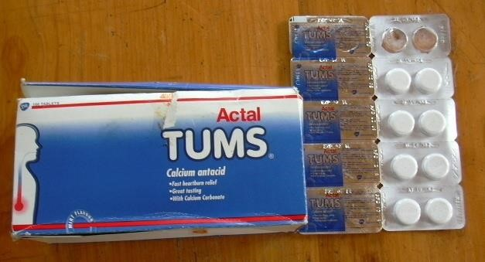
Fig. 4.13 Tums (calcium carbonate antacid) made by GlaxoSkithKline limited from calcium Carbonate for treatment of peptic ulcers

Portland cement
Portland cement, so called because it resembles Portland stone when set.
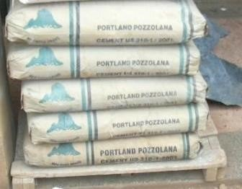

Fig 4.14 Bags of one brand of Tororo cement

Composition
The average composition of different oxides is
Lime (CaO) 50-60%
Silica (SiO₂) 20-25%
Alumina (Al₂O₃) 5-10%
Magnesia (MgO) 2-3%
Ferric oxide (Fe₂O₃) 1-2%
Sulphur trioxide (SO₃) 1%
Sodium oxide (Na₂O) 1%
Potassium oxide (K₂O) 1%

The essential constituents of cement are lime (obtained from lime stone) silica and alumina (present in clay). For cement of good quality, the oxides should be kept in following ratio

%SiO2  25 40, %CaO  1.9 2.3
%Al₂O₃ %SiO₂%Al₂O₃  Fe₂O₃
Cement containing no iron is white but hard to burn. If less lime is present than given in the ration above, the cement is low in strength and sets very soon. If more lime is there, cement cracks. Excess of silica provides slow hardening cement, while excess of alumina gives a quick-setting product.

Raw materials of cement
- Lime stone CaCO₃ provides CaO
- Clay (Al₂O₃.SiO₃. Fe₂O₃.H₂O) supplies silica (SiO₂) and alumina (Al₂O₃) some clay don’t contain Fe₂O₃ and the cement obtained in this case is white and hard to burn
- Gypsum, CaSO₄.2H₂O; these decreases the setting time of cement.

Manufacture of cement
1. Preparation of raw material or slurry. Lime stone and clay are mixed in proper ratio by any of the following process
- Dry process: This is employed when the raw material (clay and sand) are hard. In this process the lime stone is first broken into small pieces. It is then mixed with clay in proper ratio and finally pulverized to such a fine powder that 90-95 pass through a 100 mesh size. The mixture is made homogeneous to produce a raw meal.

- Wet process. This process is used when raw material Vis lime stone and clay are soft, the fuel is fairly cheap. In this process, lime stone is crushed to suitable size and the clay is washed with water in a wash mill to remove foreign materials like flint. The powdered lime stone is mixed with the clay paste in proper proportion (limestone 75% and clay 25%) and the mixture is finely ground and made homogeneous by means of a compressed air mixing arrangement. The result is a paste or slurry contains about 40% water.
2. Burning (calcinations) of raw meal or slurry in rotary Kiln.
The raw meal or slurry is heated in rotary Kiln up to 1500⁰C between 2-3 hours to cover the journey in the Kiln. Reaction taking place in the rotary Kiln can be divided into the following
- Reaction taking place in moderate temperature zone (up to 800⁰C)
In this zone, free moisture is removed and clay (Al₂O₃.2SiO₂Fe₂O₃.2H₂O is broken into Al₂O₃, SiO₂ and Fe₂O₃
Al₂O₃.2SiO₂.Fe₂O₃.2H₂O → Al₂O₃ + 2SiO₂ + Fe₂O₃ + H₂O
- Reaction taking place in average temperature zone (800⁰-1000⁰C)
Lime stone (CaCO₃) decomposes into lime (CaO) and CO₂.
CaCO₃ → CaO (s)+ CO₂ (g)
- Reaction in maximum temperature zone (1000⁰-1500⁰C)
The oxides CaO, Al₂O_{3,} SiO_{2,} Fe₂O₃ combine to together to form silicates 2CaO.SiO₂, 3 CaO.SiO_{2,} calcium aluminates, 2CaO.Al₂O₃ and tetra calcium aluminoferrite 4CaO.Al₂O₃.Fe₂O₃
2CaO + SiO₂ → 2CaO.SiO₂
3CaO + SiO₂ → 3CaO.SiO₂
2CaO + Al₂O₃ → 2CaO.Al₂O₃
3CaO + Al₂O₃ → 3CaO.Al₂O₃
4CaO + Al₂O₃ + Fe₂O₃ → 4CaO.Al₂O₃ .Fe₂O₃
The mixture of the above silicates, aluminates and tetracaliumaluminaferrite is called cement clinker.
3. Mixing the cement clinker with gypsum.
The cooled clinker is mixed with 2-3% of its weight of gypsum (CaSO₄.2H₂O). 3CaO.Al₂O₃, which is a fast setting constituent of the clinker, reacts with gypsum to form the crystal calcium suphoaluminate, 3CaO.Al₂O₃.3CaSO₄.2H₂O.
3CaO.Al₂O₃ + 3(CaSO₄.2H₂O).2H₂O → 3CaO.Al₂O₃.3CaSO₄.2H₂O + 6H₂O
Thus, gypsum removes the fast setting 3CaO.Al₂O₃ and the process of setting cement gets retarded and these results in better strength of the mass which results. The product is crushed into powder and packed.

Setting of cement
The use of cement in construction of building is based on its property of setting to a hard mass, when its paste with water is allowed to stand for some time. When cement is mixed with water, it absorbs water and the mass become hard and resistant to pressure. This is known as setting of cement. The reactions involved are
- Reactions taking place during first 24hours/short time after the cement is mixed with water, the following reactions take place
  - 3CaO.Al₂O₃ absorbs water and forms a hydrated colloidal gel of tricalciumaluminate
3CaO.Al₂O₃ + 6H₂O Hydration 3CaO.Al₂O₃.6H₂O
The gel of 3CaO.Al₂O₃.6H₂O, so formed start crystalling slowly
  - 3CaO.Al₂O₃, which is a fast setting material, reacts with gypsum (CaSO₄.2H₂O) to form crystals of calcium sulphoalminates, 3CaO.Al₂O₃.3CaSO₄.2H₂O

3CaO.Al₂O₃ + 3(CaSO₄.2H₂O).2H₂O → 3CaO.Al₂O₃.3CaSO₄.2H₂O + 6H₂O
Thus, gypsum removes the fast setting 3CaO.Al₂O₃ and the process of setting cement gets retarded and these results in better strength of the mass which results.
- Reactions taking place between 1-7days
3CaO.SiO₂ and 3CaO.Al₂O₂ get hydrolyzed according to equation
3CaO.SiO₂ + H₂O hydrolyzed Ca(OH)₂ (s) + 2CaO.SiO₂ (colloidal gel)
Ca(OH)₂ formed starts changing into needle shaped crystals which get studded in the colloidal gel 2CaO.SiO₂ formed above, and thus impart strength to it. 3CaO.Al₂O₃ + 6H₂O hydrolyzed 3Ca(OH)₂ (s)+ 3Al(OH)₃ (s)
Al(OH)₃ formed fills the interstices in hardening mass.
- Reactions taking place between 7-28days
2CaO.SiO₂ begin to hydrate (very slowly) and form the hydrate colloidal gel of dicalcium silicate of composition 2CaO.SiO₂.xH₂O
2CaO.SiO₂ + xH₂O hydration 2CaO.SiO₂.xH₂O
Needles of Ca(OH)₂ form get studded in hydrate colloidal gel of 2CaO.SiO₂.xH₂O and thus impart strength to it.

4CaO.Al₂O₃.Fe₂O₃ also gets hydrated to form a colloidal gel of composition 3CaO.Al₂O₃. 6H₂O.

4CaO.Al₂O₃.Fe₂O₃ + 6H₂O hydration 3CaO.Al₂O₃.6H₂O + CaOFe₂O₃
The gel formed above starts losing water partially by evaporation and partly by forming hydrate constituent. Thus cement sets to a hard mass.

Concrete
Concrete is a mixture of cement with sand and gravel. Concrete is used to make floors, brick and pillars that build strong building and roads, figure 9.2


(
a
)

(
b
)

Fig. 4.15 (a) concrete bricks and pillars for strong wall and (b) concrete pavers

Trial 4.20
Cement is a mixture of inorganic compounds and is widely used in construction industry.
- Namethe two processes by which cement can be made (1 ½ marks)
- Describe briefly how cement is manufactured and explain the main physical and chemical changes involved. (13marks)
- Describe what happens when water is added to a mixture of cement and sand (4½ marks)

Hydrogen carbonates of alkaline earth metals
The solid hydrogen carbonates are unknown at room temperature, but they cause temporary hardness in water. Rain water attacks any rocks containing calcium and magnesium carbonates and a dilute solution of hydrogen carbonate is formed.
CaCO₃ (s) + H₂O (l) + CO₂ (aq) → Ca(HCO₃)₂ (aq)
When water containing the dissolved hydrogen carbonates is boiled deposits of the carbonates are formed.
Ca(HCO₃)₂ (aq) ^{heat} CaCO₃ (s) + H₂O (l) + CO₂ (g)

The halide of alkaline earth metals
a. The solubility of group 2A halides increases in order MF₂ MCl₂  MBr₂  MI₂ and for any given halide, X, the solubility increases in order BeX₂ ↑MgX₂ ↑ CaX₂ ↑ SrX₂ ↑ BaX₂. Reasons
- Because the lattice (bond) energy decreases in order MF₂ MCl₂  MBr₂  MI₂.
- The ionic character increases in order BeX₂ ↑MgX₂ ↑ CaX₂ ↑ SrX₂ ↑ BaX₂.
The bromides and iodides are appreciably soluble in organic solvents such as alcohols, carbonyl compounds and ether, due to formation of complexes.

The nitrates of alkaline earth metals
They are obtained by reacting metal, oxides, hydroxides and carbonates with dilute nitric acid and crystallization of the resultant solutions.
MgO (s) + 2HNO₃ (aq) → Mg(NO₃)₂ (aq) + H₂O (l)
Ca (s) + 2HNO₃ (aq) → Ca(NO₃)₂ (aq) + H₂ (g)
Ba(OH)₂ (s) + 2HNO₃ (aq) → Ba(NO₃)₂ (aq) + 2H₂O (l)
CaCO₃ (s) + 2HNO₃ (aq) → Ca(NO₃)₂ (aq) + H₂O (l) + CO₂ (g)

Reactions of nitrates of group 2 elements
1. The nitrates decompose on heating to give the oxide, nitrogen dioxide and oxygen.
2Ca(NO₃)₂ (s) → 2CaO (s) + 4NO₂ (g) + O₂ (g)
Uses: Calcium nitrate is used as nitrogenous fertilizer e.g, CAN, NPK.

The sulphate of alkaline earth metals

Occurrence
Magnesium sulphate occurs as Epsom salts, MgSO₄.7H₂O. Calcium sulphate occurs as anhydrite, CaSO₄, and as gypsum CaSO_{4.}2H₂O.

Preparation
By reaction of corresponding metal oxides, hydroxide or carbonates with dilute sulphuric acid.
Mg (s) + H₂SO₄ (aq) → MgSO₄ (aq) + H₂ (g)
CaO (s) + H₂SO₄ (aq) → CaSO₄ (aq) + H₂O (l)
Ba(OH)₂ (aq) + H₂SO₄ (aq) → BaSO₄ (s) + 2H₂O (l)
CaCO₃ (s) + H₂SO₄ (aq) → CaSO₄ (aq) + H₂O (l) + CO₂ (g)

Solubility of group 2 metal sulphates
Like carbonates the solubility of the sulphates decreases down the group; thus, Ba²⁺ ions are used for testing for sulphate ions.
Ba²⁺ (aq) + SO₄²⁻ (aq) → BaSO₄ (s) (white ppt)

Reactions
1. Sulphates of calcium and magnesium are reduced to sulphide when heated with carbon. MgSO₄ (s) + 2C (s) → MgS (s) + 2CO₂ (g)

Uses
When heated to a temperature a little in excess of 100⁰C, gypsum loses three-quarter of its water of crystallization and become plaster of Paris, CaSO₄.¼H₂O.
Plaster of Paris sets solid, with slight expansion, on mixing with water and standing. It is widely used in making plaster casts, as a surface for walls, molds and in surgery to keep an injured limb rigid. Plaster board, which is used in building, is also made from plaster of Paris.

Ammonium sulphate, a nitrogenous fertilizer, is manufactured by reacting powdered calcium sulphate with an ammonia solution containing carbon dioxide (NH₄)₂CO₃). This reaction takes place because calcium carbonate is less soluble in water that is calcium sulphate. 2NH₃(aq) + CO₃(g) + H₂O(l) → (NH₄)₂CO₃(aq)
CaSO₄ (s) + (NH₄)₂CO₃ (aq) → CaCO₃ (s) + (NH₄)₂SO₄ (aq)

The carbides and nitride of group 2A metals
- Calcium and magnesium carbides M²⁺(CC)²⁻ can be made by reaction of the oxides with carbon at high temperatures.
CaO (s) + 3C (s) → Ca²⁺ (CC)²⁻ (s) + CO (g)
Addition of water to calcium carbide gives ethyne, which as a vital raw material in Organic chemistry.
Ca (CC) (s) + 2H₂O (l) → Ca(OH)₂ (s) + HCCH (g)
(Ethyne)
- The nitrides, (M²⁺)₃ (N³⁻)_{2,} are formed on heating metals with nitrogen.
3Mg (s) + N₂ (g) → Mg₃N₂ (s)
Addition of water causes hydrolysis and ammonia is liberated.
Mg₃N₂ (s) + 6H₂O (l) → 3Mg(OH)₂ (s) + 2NH₃ (g)

Hydrolysis of group 2A metal salts
Soluble salts of Beryllium with strong acids undergo some acidic hydrolysis. Although the majority of beryllium compound are essentially covalent, the hydrated ion [Be (H₂O)₄]²⁺ exist in solution because, beryllium ions are small and attract water molecules more strongly. The hydrolysis beryllium salts can be represented, thus:
[Be(H₂O)₄]²⁺ (aq) + H₂O (l) → [Be(H₂O)₃(OH)]⁺ (aq) + H₃O⁺ (aq)
However, salts of weak acid with the most electropositive alkaline earth metals undergo an alkaline hydrolysis in water:
H⁺ + H₂O (l) → OH⁻ (aq) + H₂ (g)
(CC)²⁻ + 2H₂O (l) → 2OH⁻ (aq) + HCCH (g)
N³⁻ + H₂O (l) → 3OH⁻ (aq) + NH₃ (g)
Magnesium chloride hydrolyzes to give a basic chloride
MgCl₂(aq) + H₂O(l) MgOHCl (s) + HCl(aq)

Qualitative analysis of Mg²⁺, Ca²⁺, and Ba²⁺
Compound containing these ions are white and when dissolved in water to give colorless solution. Unlike other white compound (Pb²⁺, Zn²⁺, and Al³⁺) which form white precipitates with sodium hydroxide that are soluble in excess, these form curdy /powder like precipitate with sodium hydroxide solutions which are insoluble in excess. Because alkaline earth metal behave very similarly to each other in aqueous solutions, it is very difficult to distinguish them and especially to separate them. The different reactions used to distinguish between them are shown in the table 9.2 below:

Table 4.16. Qualitative analysis of group 2 elements
Test | Mg²⁺ | Ca²⁺ | Ba²⁺
To 1 ml of solution add dilute sodium hydroxide drop wise until in excess | White curdy ppt.  Insoluble in excess | White curdy ppt.  Insoluble in excess | White curdy ppt.  Insoluble in excess
To 1 ml of solution add  Freshly prepared ammonia solution drop wise until in excess, followed with ammonium chloride  solution | White gelatinous ppt.  Soluble in ammonium chloride  solution | No Observable change | *  No Observable change  * With an aged solution a precipitate may occur due to formation of Barium carbonate
Ammonium carbonate followed by a few  drops of ammonium  chloride | White ppt. Soluble in ammonium chloride | White ppt. insoluble  in ammonium chloride | White ppt. insoluble in ammonium chloride
Potassium chromate followed with dilute acetic acid (30%) | No ppt. formed | No ppt. formed | A yellow ppt insoluble in acetic acid
Dilute sulphuric acid followed by conc. H₂SO₄ and boil | No ppt. formed | White ppt. Soluble in hot concentrate sulphuric acid | White ppt. Insoluble
Saturated solution of calcium sulphate | No ppt. formed | No ppt. formed | *White ppt
Ammonium oxalate solution followed by drop acetic acid | No precipitate formed | White ppt insoluble in acetic acid | White ppt soluble in acetic acid
To 1 ml add a spatula end-full of ammonium chloride followed by 1 ml disodium hydrogen phosphate | No Precipitate formed | White ppt formed | White ppt formed

Trial 4.21
(a) Name a reagent that can be used to distinguish between the following pairs of ions. In each case, state what is observed if each ion is separately treated with the reagent.
(i) Ba²⁺ and Ca²⁺ (03 marks)

TOPIC 2/3: Thermochemistry
Topic competency: The learner analyses the trends and periodic properties of elements, to explain and predict the reactivity and properties of elements in the Periodic Table.

Energy changes
In most chemical reactions there is an associated energy change, shown by the evolution of heat in an exothermic reaction /process or by absorption of heat in an endothermic reaction. It is generally possible to measure what the change is, even though it is may not be possible to determine the absolute energy levels before and after the change.

Heat changes at constant volume are known as internal energy change (∆U) while those at constant pressure are known as enthalpy changes (∆H). If no volume changes is involved ∆H = ∆U, but with a volume change, the difference between ∆H and ∆U arises because work is involved in expansion or contraction. For practical purposes, these heat changes are used interchangeably.

Heat absorbed or liberated in a reaction varies with the quantities of the reactants, the temperature and pressure at which a reaction is carried out.

Standard enthalpy changes
These are enthalpy changes when molar quantities are considered at 298K and 1 atmospheres.

Standard molar enthalpy changes are then symbolized by ∆H_{m}^{Ө}(298K) but the simpler symbol, ∆H, may be used. ∆H has negative value (heat evolved) for exothermic reaction and positive value for endothermic reaction. In thermodynamic, each enthalpy change is given a name specifying the initial and final energy level states as follows:

(a) Enthalpy of combustions
The standard molar enthalpy of combustion of a substance is the enthalpy changes when 1 mole of it is completely burn in oxygen under standard conditions.

E.g.
∆H_{c,m}^{Ө}(298K)
CH₄(g) + 2O₂(g) → CO₂(g) + 2H₂O(l) – 890.5kJmol⁻¹
C (s) + O₂(g) → CO₂(g) - 393.5kJmol⁻¹
Note that at 298K and 1 atmosphere, methane is a gas while carbon dioxide is a solid.

Experimental method for finding enthalpy of combustion a liquid fuel
The figure below shows a simple method for obtaining approximate value for the enthalpy of combustion of a fuel



Thermometer record
rise in temperature
,
Ө
0
C
Heat shield reduces
heat loss

Metal calorimeter and
water both of known
he
at capacity C, Jk
-
1

Spirit burner contains
fuel, weighing before
and after gives mass of
fuel burnt= m
1
g

Calculations
Assumption
Heat produced by combusting fuel = heat gained by water

Heat gained by calorimeter and water = CӨ joules

It implies that
m₁g of fuel produce = CӨ joules
Mr g (molecular mass of substance) produce = joulesmol⁻¹

Experimental method for finding enthalpy of combustion using a calorimetric bomb.
This method is suitable for determination of enthalpy of combustion of carbon, Sulphur or sugar but can be used on a liquid fuel

Apparatus
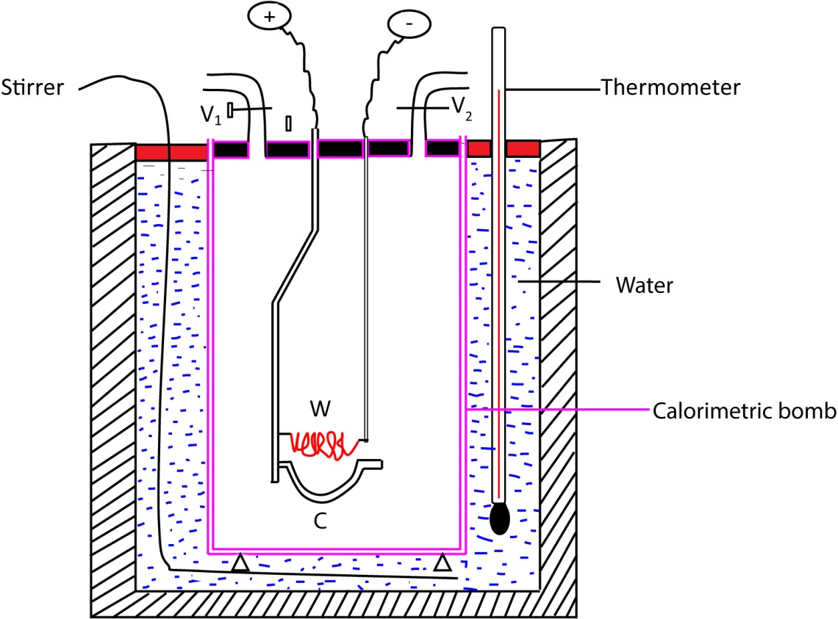

Procedure
- A known mass, m₁ g, of a substance is placed in a platinum crucible, C.
- The bomb is filled with oxygen at a pressure of about 20 atmospheres and immersed in a known mass (m_{w} g) of water which is kept stirred.
- The substance is ignited by passing an electric current through a small coil of iron wire, W.
- The rise in temperature (θ) of water is read to 0.01⁰C with an accurate thermometer.

Calculation
Heat produced by burning m₁ g of substance = heat gained by m_{w} g of water
= m_{w} x 4.2 x θ
where 4.2 is specific heat capacity of water

Therefore, enthalpy of combustion
of a substance 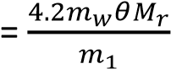

where, M_{r} is the relative molecular mass of the substance.

(b) Enthalpy of formation of compounds
The standard molar enthalpy of formation of a compound is the enthalpy change when 1 mole of the compound is formed from its elements under the standard conditions. e.g.
H₂(g) + ½ O₂ →H₂O(l) ∆H_{f,m}^{Ө}(298K) = -285.9kJmol⁻¹

Since there is no energy change in formation of an element under standard conditions; the standard enthalpies of all pure elements in their standard states is zero

(c) Enthalpy of formation of hydrated ions;
This refers to enthalpy change of the formations of 1mole of hydrated ions from an element in its standard state. e.g.
Na(s) + aq → Na⁺(aq) + e ∆H_{f,m}^{Ө}(298K) = -240kJmol⁻¹

The figures are usually quoted on arbitrary scale on which the enthalpy of formation of H⁺(aq) is taken to be zero. i.e.

½ H₂(g) → H⁺(aq) + e ∆Hf,mӨ(298K) = 0kJmol-1

(d) Enthalpy of reaction
It is enthalpy change when 1mole of a substance is formed from its reactants at standard conditions. Tabulated values of the standard enthalpies of formation of compounds and or hydrated ions can be used to calculate the standard enthalpy change for any reaction

Sum of
Standard Sum of
standard
enthalpy standard



change of a = enthalpies of - enthalpies of reaction formation of formation of
product reactants

Typical examples

NH₃(g) + HCl(g) → NH₄Cl(s)
(-46) (-92.3) (-315)

∆H_{r,m}^{Ө}(298K) = -315 – (-46 + -92.3) = -177kJmol⁻¹

The negative sign means that reaction is exothermic.

The standard enthalpy depends only on the difference between the standard enthalpy of the reactants and the products and not on the route by which the reaction occurs.

The ideal is embodied in Hess’s law, which state that, “if a reaction take place by more than one route, the overall change in enthalpy is the same whichever route is followed” or “enthalpy change of a reaction is independent of the route followed to the product”.

- Enthalpy of atomization: refers to the enthalpy change for the formation of 1mole of gaseous atoms from an element in its standard state

C(s)(graphite) → C(g) ∆H_{a,m}^{Ө}(298K) = +715kJmol⁻¹
½ H₂(g) → H(g) ∆H_{a,m}^{Ө}(298K) = +218kJmol⁻¹

- Enthalpy of ionization: refers to enthalpy change for conversion of gaseous atoms into free gaseous ions, e.g.
Na(g) → Na+(g) + e ∆H_{m}^{Ө}(298K) = +502kJmol⁻¹

Factors affecting magnitude of ionization energy
  - Size of an atom: Small atoms have strong attraction to outer electrons leading to high ionization energy.
  - Electronegativity: highly electronegative atoms have high attraction to valence electrons causing high ionization energy.
  - Electropositivity: highly electropositive atoms have low attraction to valence electrons leading low ionization energy.

- Enthalpy of electron affinity: refers to the enthalpy change for formation of free gaseous anions from1mole of free gaseous atoms.
Cl(g) + e → Cl⁻ (g) ∆H_{m}^{Ө}(298K) = -354kJmol⁻¹

Factors affecting magnitude of electron affinity
  - Size of an atom: Small atoms have strong attraction to outer electrons leading to high negative electron affinity.
  - Electronegativity: highly electronegative atoms have high attraction to valence electron causing high negative electron affinity
  - Electropositivity: highly electropositive atoms have low attraction to valence electrons leading high positive electron affinity.

(h) Lattice enthalpy
This is the name given to the enthalpy change for the reaction in which 1mole of crystalline solid is formed from its component ions in the gaseous phase.

Na+(g) + Cl-(g) → NaCl(s) ∆H_{m}^{Ө}(298K) = -788 kJmol⁻¹

Factors affecting the magnitude of lattice energy
- Size of the ion; small ions have strong interionic attraction causing high lattice energy
- Charge on the ions: ions with big charge have strong interionic attraction leading to high lattice energy.

(i) Enthalpy of solution
This refers to the enthalpy change for the formation of an infinitely dilute solution of 1 mole of salt.

NaCl(s) +aq→ Na⁺(aq) + Cl⁻ (aq) ∆H_{m}^{Ө}(298K) = +4 kJmol⁻¹

Factors affecting the magnitude of enthalpy of solution

Enthalpy of solution = lattice energy (+ve) + sum of hydration energy of ions (-ve)

When the lattice energy exceeds the sum of hydration energies of the ions, the enthalpy of solution is positive (endothermic) and the salt is insoluble.

When the lattice energy is less than the sum of hydration energies of the ions, the enthalpy of solution is negative (exothermic) and the salt is soluble.

(j) Enthalpy of hydration
This refers to the enthalpy change when 1mole of gaseous ions is hydrated. e.g.

Na⁺(g) + aq → Na⁺(aq) ∆H_{m}^{Ө}(298K) = -406 kJmol⁻¹

Factors affecting the magnitude of hydration energy
- Size of the ion: small ions have strong attraction to water molecules leading to high hydration energy.
- Charge on the ions: ions with high big charge have a strong attraction to water molecules leading to high enthalpy of hydration.

(k) Enthalpy of neutralization
This refers to enthalpy change for the formation 1 mole of water is formed from hydrogen and hydroxide ions
H⁺(aq) + ⁻OH(aq) → H₂O(l)

Measurement of standard enthalpy of neutralization
The heat released when a known amount of water is formed is found by measuring the temperature produced in a calorimeter and its contents.
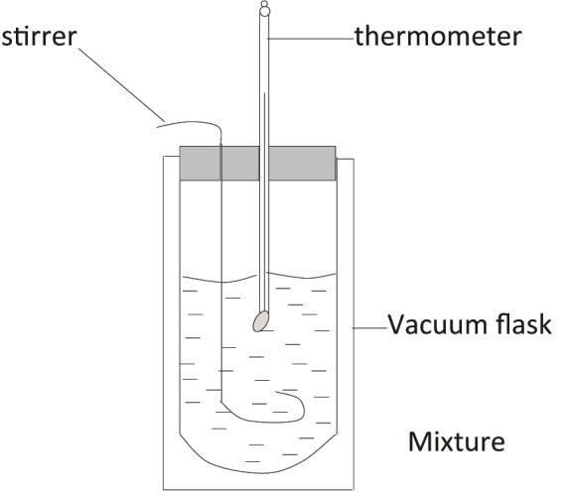

A neutralization reaction is carried out in the calorimeter of known heat capacity, C .

Know volume of standard acid (v cm³) and alkali (v cm³) are added to calorimeter, and temperature change θ⁰C is noted.

The number of moles of water formed, X moles, is calculated

Calculations

Assumptions:
- The density of water = density of solution = 1gcm⁻³.
- Specific heat of solution = specific heat capacity of water = c Jg⁻¹K⁻¹
- Heat given out on neutralization = Heat received by water + calorimeter of capacity, C.

Thus, heat given out = Cθ + (v+v)cθ
Thus X mole of water formed produce = (Cθ + 2vcθ)J
1mole of water produced requires 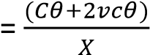 Jmol⁻¹

Example 1
250 cm³ of 0.40M were added to 250cm³ of 0.40M HCl in the calorimeter heat capacity of 90 J K⁻¹. The temperature of the two solutions was 17.5⁰C and rose to 20.1⁰C

Calculate the enthalpy of neutralization assuming that the specific heat capacities of solution are the same as that of water = 4.180J g⁻¹ K⁻¹.

Calculation
Temperature change θ = 20.1 – 17.5 = 2.6⁰C

Heat liberated = (Cθ + 2vcθ)J
= 90 x 2.6 + (250 + 250) x 4.180 x 2.6)
= 5668J

Moles of water formed = moles of NaOH
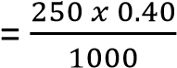
= 0.1mole
Molar hat of formation of water 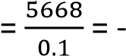56680Jmol⁻¹.
The negative sign signify that heat is liberated.

Enthalpy diagrams
These are constructed by application of Hess’s law: that states “enthalpy change of a reaction is independent of the route followed to the product.” For instance, the enthalpy change for conversion of carbon into carbon dioxide is the same whether it is carried out in one step;

C(s) + O₂(g) → CO₂ (g) ΔH_{m}^{Ѳ}(298K) = -393.5 kJ mol⁻¹

Or two steps

C(s) + ½ O₂(g) → CO (g) ΔH_{m}^{Ѳ}(298K) = -110.5 kJ mol⁻¹

CO(s) + ½ O₂(g) → CO₂ (g) ΔH_{m}^{Ѳ}(298K) = -283.0 kJ mol⁻¹

The relationship between various enthalpy changes is conveniently summarized in an enthalpy diagram below.



C (s) + O
2
)
g
(

-
393.5

kJ mol
-
1

0

-

110.5

kJ mol
-
1

-
kJ mol
283.5
-
1

CO (g) + ½ O
2

)
g
(

CO
2

g
(
)

Such diagrams are used to obtain values for enthalpy changes that cannot be measured directly. The enthalpy of formation of methane cannot be measured directly since carbon and hydrogen do not react for example;
C(s) + 4H₂ (g) → CH₄(g) ΔH_{m}^{Ѳ}(298K) =x kJ mol⁻¹
The enthalpies of combustion of carbon (-393.5 kJ mol⁻¹), hydrogen (-289.9 kJ mol⁻¹) and methane (-890.5 kJ mol⁻¹) can however be measured and the required enthalpy of formation is obtained from them (X = -82.8kJmol⁻¹) as summarized in figure below:



i.e.
X

+

(
-
890.5) =

-
393.5 + 2(
-
2
89.9)

C (s) + 2H
2

g
(
)

0

-
82
.8

kJ mol
-
1

-
890.5
kJ mol
-
1

CH
4

CO
2

(
g) +
2
H
2
O) l
)

X =
-
kJ mol
74.8
-
1

-
9
73

.3

kJ mol
-
1

O
2
2

(
)
g

= -82.8kJmol⁻¹

Standard enthalpy for a reaction from average standard bond enthalpies

When the standard enthalpy for a reaction cannot be measured, approximate value can be obtained by using average standard bond enthalpies. During reaction energy must be supplied to break bonds in the reactants and energy is given out when the bonds in the product form.

The Standard enthalpy of reaction | = | sum of the average bond of reactants | - | sum of the average bond of products

Example2
Calculate the standard enthalpy change the reaction

OH
(CH₃)₂C=O (g) + HCN → (CH₃)₂C


CN

Mean standard enthalpies are C=O = 743, C-H = 412; C-O = 360, C-C = 348, H-O = 463.

Method
Bond broken | One  one | C=O  C-H | ΔHθ  ΔHθ | 743 kJ mol⁻¹  412 kJ mol⁻¹
Total energy absorbed |  |  |  | 1155 kJ mol⁻¹

Bond formed | One  One  one | C-O  O-H  C-C | ΔHθ  ΔHθ  ΔHθ | 360 kJ mol⁻¹  463 kJ mol⁻¹  4348 kJ mol⁻¹
Total energy produced |  |  |  | 1171 kJ mol⁻¹

Standard enthalpy of reaction = 1155 -1171
= -16 kJ mol⁻¹.

Exercise
- (a) The thermo energy changes for some process are shown in the table below
Process Energy (kjmol⁻¹)
Atomization of calcium +178 First ionization energy of calcium +590
Second ionization energy of calcium +1146
Formation of calcium fluoride -1220
Electron affinity of fluorine -328
Bond dissociation energy of fluorine +242.7
  - Calculate the lattice energy of calcium fluoride crystal. (02marks)
  - Determine the enthalpy of solution of calcium fluoride
[enthalpy of hydration of Ca²⁺ and F⁻ ion are -1587 and – 515 kJmol⁻¹ respectively]
  - (i) state the effect of temperature on solubility of calcium fluoride (01mark)
    - give a reason for your answer

- (a) Define standard enthalpy of formation (01mark)
  - some thermochemical data for calcium, calcium chloride and chlorine are given below.
Energy (kjmol⁻¹)
Formation of calcium chloride -763
Atomization of chlorine +121
Atomization of calcium +193
First ionization energy of calcium +590
Second ionization energy of calcium +1145
Electron affinity of chlorine -348
  - Draw an energy diagram for formation of solid calcium chloride (04marks)
  - Calculate the lattice energy of calcium chloride. (2 ½ marks)
  - If calcium formed a chloride in which calcium was in oxidation state of +1, would it be more or less stable than calcium chloride? Explain your answer. (03marks)
  - (i) Calculate the enthalpy of solution of calcium chloride [ enthalpies of hydration of Ca²⁺ and Cl⁻ are -1689.6 and – 383.7kJmol⁻¹ respectively] ( 2 ½ marks]
    - comment on the solubility of calcium chloride. (01mark)
  - (i) State two factors that can affect the magnitude of hydration energy. (02marks)
    - Explain how the factors you have stated in (e)(i) affect hydration energy. (04marks)
- (a) State
    - What is meant by the term first ionization energy. (01marks)
    - Two factors that determine the value of the first ionization energy and explain how the factors affect the value of the first ionization energy
  - (i) Define the term first electron affinity. (01mark)
    - Explain why the first electron affinity of oxygen is exothermic process while the second electron affinity is endothermic process

  - Aluminium reacts with oxygen to form aluminium oxide according to the following equation
2Al(s) + 3/2 O₂(g) Al₂O₃(s)ΔH0 = -1675.7kJmole⁻¹

Some thermodynamic data of aluminium and oxygen are given below
(c) | Enthalpy of atomization of oxygen | = | +249kmol⁻¹
 | Enthalpy of atomization of aluminium | = | +324 kmol⁻¹
 | First ionization of aluminium | = | +578.0kmol⁻¹
 | Second ionization of aluminium | = | +1817.0 kmol⁻¹
 | Third ionization of aluminium | = | +2745.0 kmol⁻¹
 | First electron affinity for oxygen | = | -141.4 kmol⁻¹
 | second electron affinity for oxygen | = | +844.0 kmol⁻¹
(i) | Draw an energy level diagram for the formation of aluminium oxide |  | 5makrs
(ii) | Calculate the lattice energy of aluminium III oxide |  | 2 ½ marks
(iii) | Comment on the value of the lattice energy in (c)(ii) |  | 1 ½ marks

- The energy changes that take place during the formation barium chloride are shown below
Proces
s

∆
H
θ

/kJmol
-
1

Ba (s) A Ba(g)

+176

Ba(g) B Ba
2+
(
g) + 2e

+1480

Cl2(g) C 2Cl(g) +224
Cl (g) + e- D Cl⁻(g) -364
Ba²⁺(g) + 2Cl⁻(g) E BaCl₂(s) -2018
  - Name energy changes for the processes: A, B, C, D, and E.
  - Calculate the standard enthalpy of formation of barium chloride (03marks)
- (a) Describe an experiment that can be carried out to determine the enthalpy of solution of sodium chloride (09marks)
  - In an experiment to determine the enthalpy of anhydrous copper (II) sulphate by indirect method.4.0g of anhydrous salt was added to 50.0g of water and the temperature of water rose 8.0⁰C.
When 4.0g of the hydrated salts was added to 50.0g of water, the temperature of water dropped by 0.90C.
[Specific heat capacity of solution = 4.2Jg⁻¹K⁻¹; Cu = 64, S = 32, O = 16, H = 1)

Calculate the enthalpy of solution of
  - Anhydrous copper (II) sulphate (3marks)
  - Hydrate copper (II) sulphate- 5-water
  - (i) State which one of two copper salt in (a) is more soluble in water and explain your answer.
(ii) determine the enthalpy of hydration copper (II) sulphate (02marks)

- Enthalpy of formation of phosphorus trichloride is -306kJmol⁻¹ and enthalpy of atomization of phosphorus and chlorine are +314 and 242Kjmol⁻¹ respectively. Calculate the average bond energy of the P-Cl bond.

- The enthalpies of some reactions are given below
∆Hθf/kJ mol⁻¹
  - Na₂O(s) + H₂O(l) 2NaOH(s) ∆H₁^{θ} -205

  - NaOH(s) + (aq) NaOH(aq) ∆H₂^{θ} -56.5
  - Na(s) + H₂O(l) + (aq) NaOH (aq) + ½ H₂(g) ∆H₃^{θ} -410
  - H₂(g) + ½ O₂(g) H₂O(l) ∆H₄^{θ} -285.8
Calculate enthalpy of formation of sodium oxide from its elements (4marks)

8 (a) (i) Define the enthalpy of solution (1mark)
  - State the energy terms that determine the magnitude and the sign of the enthalpy of solution of ionic salt.
  - Describe an experiment that can be of used to determine the enthalpy of solution (b) Some thermochemical data of copper, cupper (II) chloride and chlorine are given below:
Enthalpy of formation of copper chloride |  | -220 kJmol⁻¹
Enthalpy of sublimation of Cu |  | +338.3 kJmol⁻¹
First ionization of copper |  | +745 kJmol⁻¹
Second ionization of copper |  | +1954 kJmol⁻¹
Electron affinity for chlorine |  | -364 kJmol⁻¹
Bond dissociation energy | of
chlorine |  | +121 kJmol⁻¹
- Draw an energy level diagram which can be used to determine the lattice energy of copper
(II) chloride. (4marks)
- The hydration energy of copper (II) chloride is -2883.9 kJmol-1. Determine the enthalpy of solution of copper (II) chloride. (3marks)
- Comment on the solubility of copper (II) chloride. (1mark)
9. (a) Define the following terms:
  - Hydration energy
  - Lattice energy
  - Enthalpy of solution
- State two factors which can affect the magnitude of lattice energy and explain how they affect the lattice energy.
- Some thermochemical data are given below

The standard enthalpy of formation of CaCl₂ (s) | = | -795 kJmol⁻¹
The standard enthalpy of atomization of calcium |  | +177kJmol⁻¹
The first ionization of calcium | = | +590kJmol⁻¹
The second ionization of calcium | = | +1100kJmol⁻¹
The standard enthalpy of atomization of chlorine | = | +121kJmol⁻¹
The first electron affinity of chlorine | = | -364kJmol⁻¹
Calculate the lattice energy of calcium chloride
(2marks)
- The lattice and hydration energies of salts AX and BX are given in the table below
 | Lattice energy/kJmol⁻¹ | Hydration energy/kJmol⁻¹
AX | +880 | -860
BX | +790 | -800

- Calculate the enthalpy of solution of each salt (3marks)
- Which of the two salts is more soluble in water at a gives temperature? Give a reason.
- Explain why hydrated copper sulphate crystals dissolve endothermically whereas anhydrous copper sulphate dissolve exothermically

10.(a) | (i) | Explain what is meant by the term lattice energy. |  | (2marks)
 | (ii) | State two factors that affect the magnitude of lattice energy. |  | (2marks)
 | (iii) | Describe how the factors you have stated in (ii) affect lattice energy. |  | (6marks)
(b) | (i) | Draw a Born-Haber cycle for the formation of solid rubidium chloride from its elements |  | (6marks)
 | (ii) | Calculate the electron affinity of chlorine atom. Use the following data |  | (3marks)
 | Lattice energy of rubidium chloride |  | = | 665kJmol⁻¹
 | Dissociation energy of chlorine gas molecule |  | = | 226kJmol⁻¹
 | Heat of atomization of rubidium meal |  | = | 84kJmol⁻¹
 | Ionization energy of rubidium atom |  | = | 397kJmol⁻¹
 | Standard heat of formation of solid rubidium chloride |  | = | -439kJmol⁻¹

(c) Calculate the heat of hydrogenation of ethane from the following thermodynamic data. C₂H₄(g) + 3O₂(g) 2CO₂(g) + 2H₂O(l) ΔH = -1393kJmol⁻¹
C₂H₂ (g) + 2 ½ O₂(g) 2CO₂(g) + H₂O(l) ΔH = -1310kJmol⁻¹
H₂(g) + ½ O₂(g) H₂O(l) ΔH = -285kJmol⁻¹
( 3marks)
.
11. The energy diagram for the reaction between hydrogen and chlorine is given below
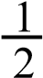
H
2
(
g
)
1
2
C
l
2
(
g
)
H
C
l

(
g
)
H
(
g
)
C
l
(
g
)
A
B
C
D

(a)Identify the energy changes
A………………………………………………………………….
B ………………………………………………………………… C …………………………………………………………………
D …………………………………………………………………
(b) Calculate the enthalpy change for the reaction.
(The H-H, Cl-Cl and H-Cl bond energies are 435.9, 241.8 and 431.0 kJmol⁻¹ respectively) (1½ marks).

12. (a) Some bond energies are given in the table below
Bond | Energy (kJmol⁻¹)
C-C | -337
C-H | -414
C-O | -360
O-H | -123
Calculate the heat of formation of gaseous ethanol (3marks)
(b) Carbon monoxide burns in oxygen according to the following equation.
2CO (g) + O₂(g) 2CO₂(g)
Calculate the enthalpy of combustion of carbon monoxide.
(Heats of formation of carbon monoxide and carbon dioxide are -108 and -393kJmol⁻¹ respectively.)

13(a) What is bond energy? (2marls)
(b) The figure below represents the energy diagram for formation of methane
C
(
s
)

+

2
H
2
(
g
)
C
(
g
)
4
H
(
g
)
C
H
4

(
g
)
H
2
H
4
H
1
H
3

Identify the following energy changes: 3marks
ΔH₁ …………………………………………………………….
ΔH₂ …………………………………………………………….
ΔH₃ …………………………………………………………….

Given that ΔH₁ = -75 kJmol⁻¹
ΔH₂ = +218 kJmol⁻¹ of hydrogen atom
ΔH₃ = +715 kJmol⁻¹ Calculate the value of:
- ΔH₄ (2marks)
- The bond energy for C-H bond (2marks)

14 (a) Methane reacts with chlorine in the presence of sun light to form chloromethane. write equation for the reaction and outline mechanism for the reaction.
(b) Some bond energies are given below
Bond | Energy/kJmol⁻¹
Cl-Cl  C-H  Cl-H  C-Cl | 242  435  431  339

Determine the enthalpy change for the reaction. (3marks)
.

Suggested answers
1(a) (i) -1220 = 178 + 590 + 1146- 328 x 2 +242.7 + ∆H Lattice
⇨ ∆H Lattice = -2720kJmol⁻¹
(ii) ∆solution = lattice + hydration energies
=2720.7 –(1587 + 515 x2)
= 103.7 kJmol⁻¹
(b) (i) Increasing temperature increases solubility of calcium fluoride.
(ii) enthalpy of solution for CaF₂ is endothermic
2. (a) Standard enthalpy of formation is enthalpy change when 1 mole of a substance is formed from it elements at 298K and 1 atmosphere.
(b)(i)

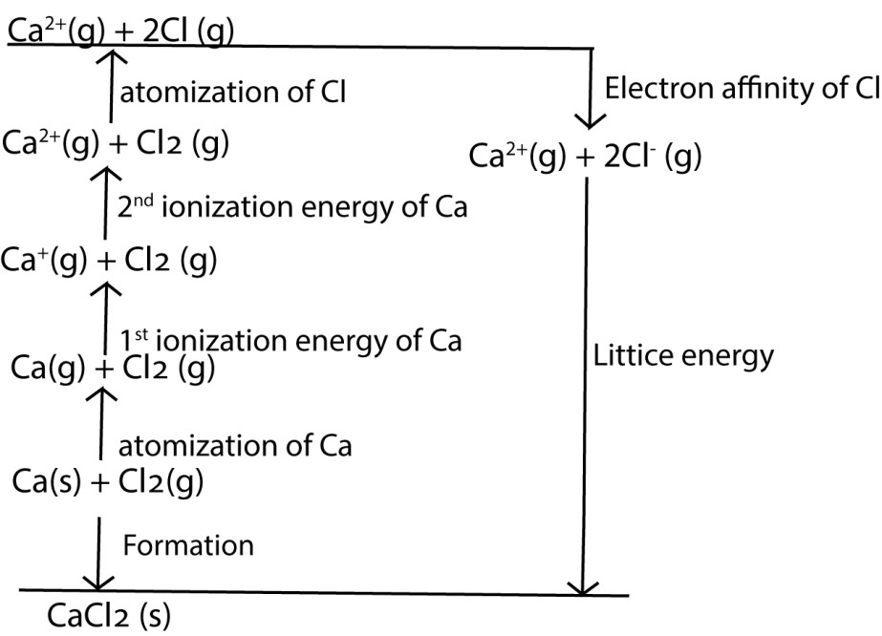
(ii) -763 = 193 + 590 + 1145 + 121 x 2 – 348 x 2 + lattice energy Lattice energy = -2237 kJmol⁻¹
(a) It would be less stable because Ca+ has unstable electron configuration. (b) (i) enthalpy of solution = lattice energy + hydration energy
= 2237 –(1689.6 + 383.7 x 2)
= -220kJmol-1
(ii) Calcium chloride is soluble because its enthapy of solution is negative
(e)(i) Charge on the ions
Size of the ions
(ii) – The bigger the charge on the ions, the higher the hydration energy because of strong forces between the ion ans water molecules
- The smoller the ions the stronger the force of attration between the ion and water molecules and the higher the hydration enrgy.
3.(a)(i) First inosation energy is the enthalpy change when 1 mole of gaseous atoms are converted into 1 mole of gaseous ions with a single postive charge
(ii) Factor affecting first ionization energy
- Nuclear charge on valence electrons:the higher the nuclear charge on the valence electron the higher the first ionization energy due to strong attaction of the nucleus to valence elelctrons.
- Electronegativity: the higher the electronegativity, the higher the first ionization energy due to strong nuclear attraction on the valence electrons.
- Atomic radius: increase in atomic radius reduce attraction of the nucleus on the valence electrons and reduces first ionization energy.
- Electropositivity: the higher the electronegativity, the lower the first ionization energy due to low nuclear attraction on the valence electrons
(b) (i) First electron affinity is the enthalpy change when 1mole of gaseous atoms is converted into 1 mole of gaseous anions with single negative charge
  - O(g)→ O⁻(g)
  - - first electron affinity of oxygen is exothermic bcause oxygen atoms are highly electronegative with strong attraction to valency electrons.
- The second electron affinity is positive because the added electron added repels the second electrons.
(c)
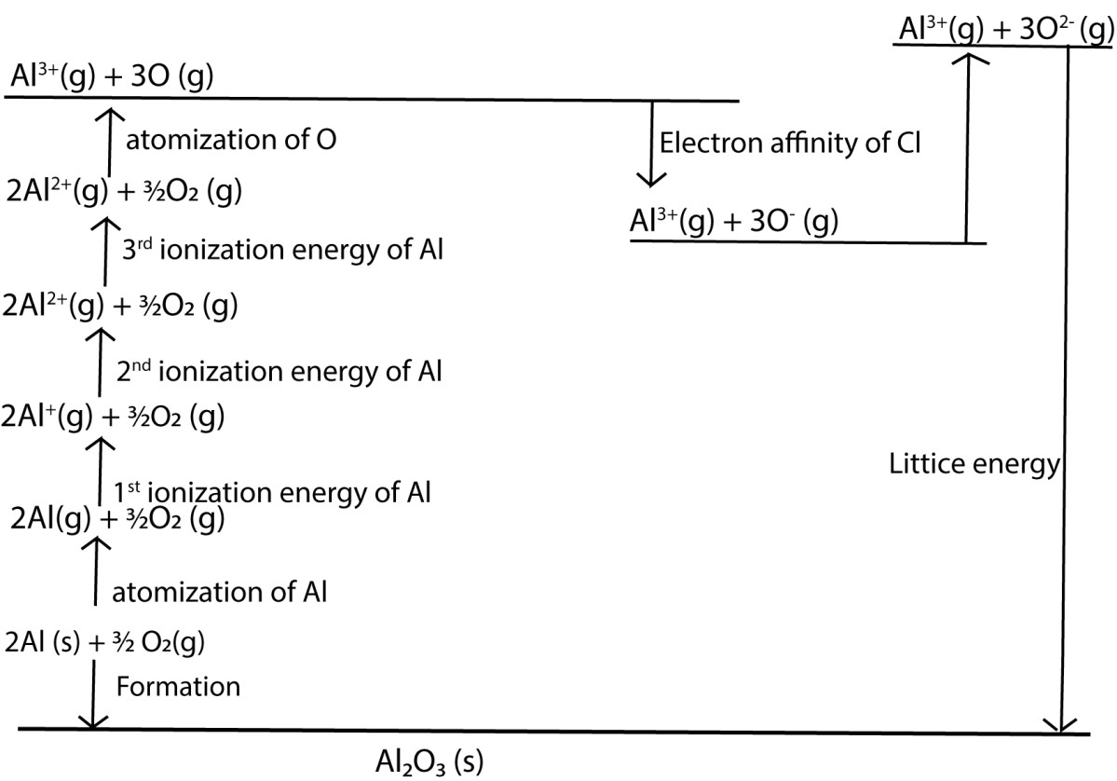
(
ii)
-
1675.7 = 324.5
x 2 +578 x 2 + 1817 x 2 + 2745 x 2 +249.2 x
3
-

141.4
x 3 + 844 x 3
+
∆
H lattice

∆
H lattice =
-
15460.1
kJmol
-
1

(iii) Lattice energy is very high showing that aluminium oxide is very stable.
4. (a) A – atomization energy of barium
- – ionization energy of of barium
- – bond energy of chlorine
- – electron affinity of chlorine
- – lattice energy
(b) ∆Hf = +176+ 1480 + 242 +-364 x 2 – 2018 = -848kJmol⁻¹.
5. (a) A given mass m g of sodium chloride is dissolved in x g of excess water and the temperature change θ⁰C is measured.
Assumptions
Heat liberated = heat absorbed by water
= xcθ (where c is specific heat capacity of water)
Formula mass of NaCl = 23 + 35.5 = 58.5g
- m g of NaCl liberate xcθ J
- 58.5g of NaCl will liberate 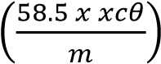Jmol⁻¹
(b) (i) Heat liberated = mcθ
= 50 x 4.2 x 8
= 1689 joules
Formula mass of CuSO₄ = 64 + 32 + 16 x 4
= 160g
4.0g of CuSO4 liberate 1680J
160g of CuSO₄ liberate 67.2kJmol⁻¹
ii) Heat absorbed = mcθ
= 50 x 4.2 x 0.9
= 189 joules
Formula mass of CuSO₄.5H₂O | = 64 + 32 + 16 x 4 + 5(2 + 16)
4.0g of CuSO4 absord 189J | = 250g
250g of CuSO₄ liberate 11.812kJmol⁻¹
(c) (i) anhydrous copper (II) sulphate is more soluble because it liberates heat on dissolving.
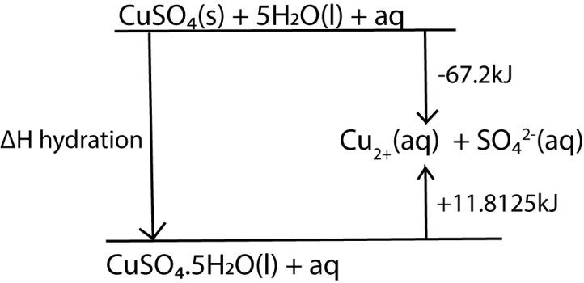
(ii)

Enthalpy of hydration = -67.2 – 11.8125 = 79.125kJ

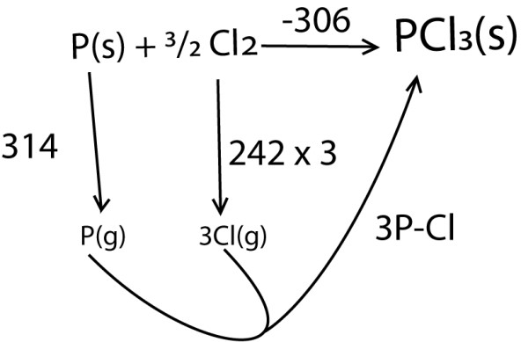
6.

-306 = 314 + 242 x 3 + 3P-Cl
P-Cl = 448.7kJmol⁻¹
7. ∆Hθf/kJ mol⁻¹
reverse equation (i)

2
NaOH(s)

Na
2
O(s) + H
2
O(l)

205

reverse (ii) x 2

2
NaOH (aq
)

2
NaOH (s) + 2(aq
)

x
56.5
2

113

equation (iii) x2

2
Na(s) +
2
H
2
O(l) + (aq)

2
NaOH (aq) + H
2
)
g
(

x
2
-
410

=

-
820

equation (iv)

H
2
(
g) + ½ O
2
)
(
g

H
2
O(l)

-
285.8

2
Na(s) + ½ O
2

N
2
O(s)

-
787.8

8 (a)(i) Enthalpy of solution is enthalpy change when 1 mole of ionic salt is dissolved in excess water.
- Lattice energy and hydration energy
- Experiment to determine enthalpy of solution
A given mass m g of ionic salt of molecular mass (Mr) is dissolved in x g of excess water and the temperature change θ⁰C is measured.
Assumptions
Heat liberated = heat absorbed by water
= xcθ (where c is specific heat capacity of water)
m g of NaCl liberate xcθ J
⇨ Mr g of NaCl will liberate 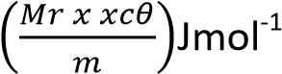
(b)
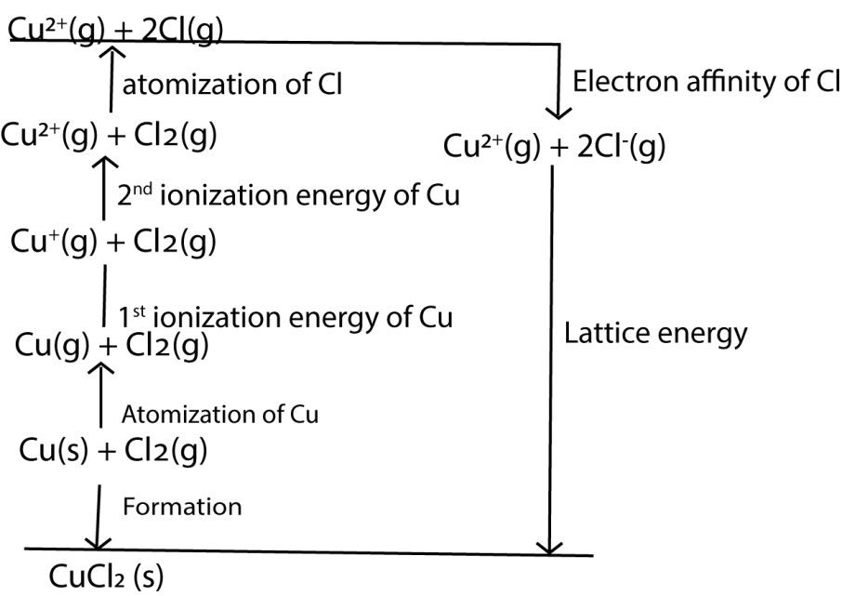
Lattice energy = -220-338.3-745-1958-121.1+364 x 2 = 2654.4kJmol-1
- Enthalpy of solution = lattice energy + hydration energy
= 2654.4 -2883.9
= 229.5kJmol-1
- Cupper II chloride is soluble because enthalpy of solution is negative
9. (a) (i) Hydration energy is enthalpy change that occur when 1mole of gaseous ions is hydrated at 298K and 1 atmosphere.
  - Lattice energy is enthalpy change when 1 mole of crystalline ionic compound is dissolved in excess water.
  - Enthalpy of solution is enthalpy change when 1 mole of ionic salt is dissolved in excess water
- (i) charge on the ions: the bigger the charge on ions the bigger the lattice energy due to strong attraction
(ii) size of the ion: small ions give high lattice energy due to strong attraction.
- -795 = 177 + 590+ 1100+121 x2 – 364 x 2 + ∆HL
∆HL = -2176kJmol⁻¹
(d)(i) enthalpy of solution of AX = 880-860 = 20kJmol-1
  - enthalpy of solution of BX = 790-800 = -10kJmol⁻¹
  - Bx is more soluble because enthalpy of solution is negative
(e) Enthalpy of solution of hydrated copper (II) sulphate is positive because it involves breakage of bonds of hydration in the crystal lattice during dissolving
Enthalpy of solution of anhydrous copper (II) sulphate is exothermic due to formation of coordinate bonds between the copper ions or sulphate ions with water molecules to form complex ions

10. (a) (i) Lattice energy is enthalpy change when 1 mole of crystalline ionic compound is dissolved in excess water.
- charge on the ion and size of the ion
- - charge on the ions: the bigger the charge on ions the bigger the lattice energy due to strong attraction
- size of the ion: small ions give high lattice energy due to strong attraction.
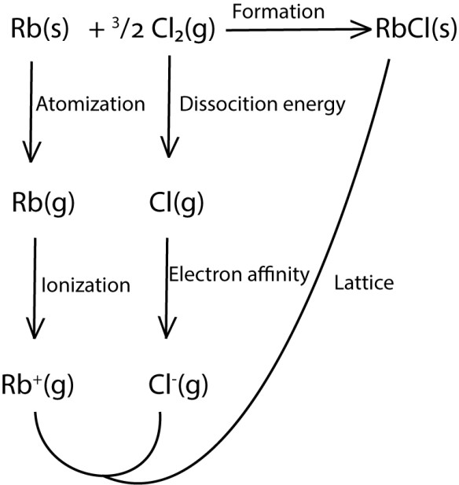
(
b
)

-439 = 84 + 397 + ½ x 226 + electron affinity – 665
Electron affinity = -368kJmol⁻¹
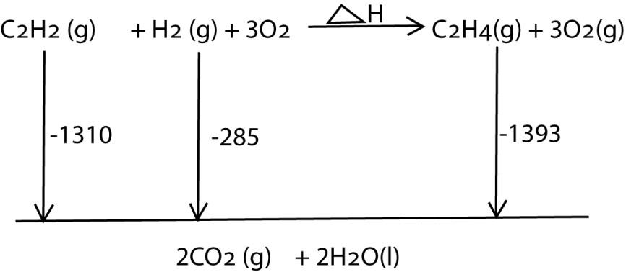
(c)

-1310 – 285 = ∆H – 1393
∆H = -202kJmol⁻¹
11. (a) A – atomization of hydrogen gas
        - – atomization of chlorine gas
        - – bond energy
        - – formation
(b) D = 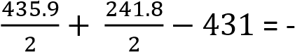 92.15kJmol⁻¹
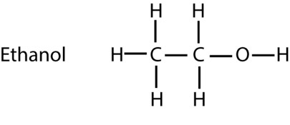
12.

Ethanol has 5C-H bonds = -414 x 5
1C-C bond | = -337 x 1
1C-O bond | = -360 x 1
1O-H bond | = -123 x 1
Heat of formation = (sum) | = -2890kJmol⁻¹

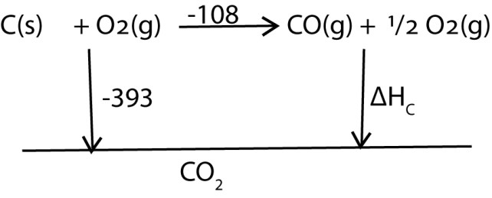
(b)

-393 = -108 + ∆Hc
∆Hc = -385kJmol⁻¹
13. (a) Bond energy is energy change required to form 1 mole of a gaseous covalent bond.
(b) ∆H1 = enthalpy of formation
∆H2 = atomization energy of hydrogen
∆H3 = atomization of energy carbon

∆H1 = ∆H3 + ∆H2 + ∆H4
-75 = 715 + 218 x 4 + ∆H4
∆H4 = -1662
v
C-H bond = 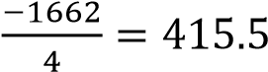kJmol-1

14. CH₄ (g) + Cl₂(g) CH₃Cl (g) + HCl(g)
Enthalpy change = sum of enthalpies of bonds broken – sum of enthalpies of bonds formed
= [4C-H +1Cl-Cl] –[3C-H + 1C-Cl + 1 H-Cl]
= [4 x 435 + 242] – [3 x435 + 339 + 431]
= 93kJmol⁻¹

TOPIC 3/3: Organic Chemistry I PART 1
Topic competency: The learner analyses the structures, functional groups, and reactivity of organic compounds, and applies knowledge of organic reactions and organic reaction mechanisms to synthesise organic molecules.

Introduction
Organic is the study of the chemistry of carbon. Carbon out of 112 elements of the Periodic Table forms a branch of chemistry called organic chemistry; it must be unique.
Uniqueness of carbon
Carbon forms very many useful compounds of different chemical and physical properties.
Uses of organic compound
Organic compounds are used for making:
- Plastic chairs,
- Plastic tables,
- drugs,
- perfumes
- pens
- paper
- Herbicides.
Terminologies in organic chemistry
1. Hydrocarbons
These are compounds that contain carbon and hydrogen only.

2. Functional groups
Is an atom or groups of atoms that impart chemical properties to organic compounds. For instance, a double bond in alkenes (–C=C-), a triple bond in alkynes (-C≡C-), hydroxyl group in alcohols (-OH), a halogen a tom in alkylhalides, carbonyl (-CO-) group and a carbocylic group (-COOH).

3. Homologous series is group of organic compounds that
- are represented by similar general formula,
- have similar functional group and hence similar chenical properties
- are prepared by simila chemical methods
- show varying chenical properties. For instance, members of a given homologous series may vary from gases to liquids to solids.

Alkanes
This is the simplest homologous series
General formula: C_{n}H_{2n}+2 where n ≥1

Examples
Formula | Structural formula |  | Name
CH₄ | H  H  C  H  H |  | Methane
C2H6 | H  C  H  H  H  C  H  H |  | Ethane
C3H8 | H  C  H  H  H  C  H  H  C  H | H | Propane

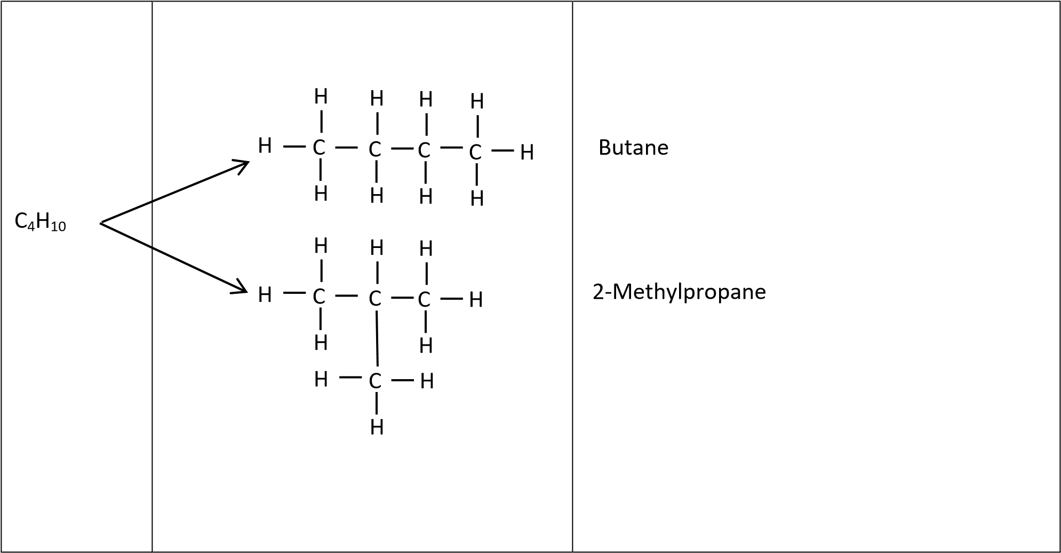

Compounds that have the same molecular formula but different structural formulae like butane and 2-methylpropane are called isomers.

Definitions
Isomerism is the existence of compounds with the same molecular formula but different arrangement of atoms in each of the compounds.

Types of isomerism
- Structural isomerism
- Optical isomerism

(a) Structural isomerism
Here compounds differ in arrangement of atoms in isomeric compounds.
- Chain isomerism: compounds have the same molecular formula but different arrangement of atoms in the chains. Some authors use chain isomerism and structural isomerism interchangeably. This kind of isomerism is common to alkanes, e.g.




C
4
H
10

H

C

H

H

H

C

H

H

C

H

H

C

H

H

C

H

H

H

H

C

H

H

H

C

H

C

H

H

Butane

2
-
Methylpropane

- Functional isomerism
Compounds have the same molecular formula but different functional groups such as alcohols and ether, e.g.



H

C

H

H

H

C

OH

H

H

C

H

H

H

C

O

H

H

Ethanol

Diethylether


C₂H₆O

- Positional isomerism:
The isomers have the same molecular formula, same functional group but different positions of the functional group on each molecule, e.g.
CH₃CH₂CH=CH₂ but-1ene
CH₃CH=CHCH₃ but-2-ene
(b) Stereo isomerism
Compounds have the same molecular formula, the same functional group but different arrangement of atoms in space.
(i) Geometrical isomerism: atoms, molecules are arranged differently about a double bonds:

Example
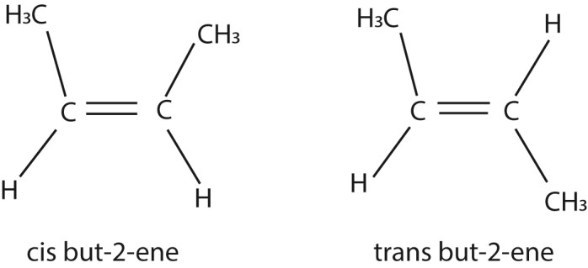

(ii) Optical isomers:
Compounds have the same molecular formula, the same functional group but differ in optical properties towards plane polarized light. Those that rotate light towards the right are called dextroisomers and those that rotate light towards the left are called levo-isomers. They characteristically have four different groups attached to one carbon and are mirror images, i.e.
b

C

a

c

d

b

C

c

a

d

Nomenclature
(a) Straight chain isomers
Straight chain isomers are named according to the number of carbon atoms in the chain.

The names of the first ten straight chain isomers are given below
CH₄ Methane
CH₃CH₃ Ethane
CH₃CH₂CH₃ Propane
CH₃CH₂CH₂CH₃ Butane
CH₃CH₂CH₂CH₂CH₃ Propane
CH₃CH₂CH₂CH₂CH₂CH₃ Hexane
CH₃CH₂CH₂CH₂CH₂CH₂CH₃ Heptane
CH₃CH₂CH₂CH₂CH₂CH₂CH₂CH₃ Octane
CH₃CH₂CH₂CH₂CH₂CH₂CH₂CH₂CH₃ Nonane
CH₃CH₂CH₂CH₂CH₂CH₂CH₂CH₂CH₂CH₃ Decane

Alkyl group
An alkyl group is an alkane less one hydrogen atom. Examples
CH₄ Methane CH₃- | methyl group
CH₃CH₃ Ethyl CH₃CH₂- | Ethyl group
CH₃CH₂CH₃ Propane CH₃CH₂CH₂- | Propyl group
CH₃CH₂CH₂CH₃ Butane CH₃CH₂CH₂CH₂- | Butyl group

Because alkyl group do not show variable chemical properties, they are generally represented by a letter R. However, the length of an alkyl group may influence level of reactivity of a function group
(b) Naming branched alkanes
- Determine the number of carbon atoms in the longest carbon chain that contain a branch.
- Number the carbon atoms from the side nearest the branch.
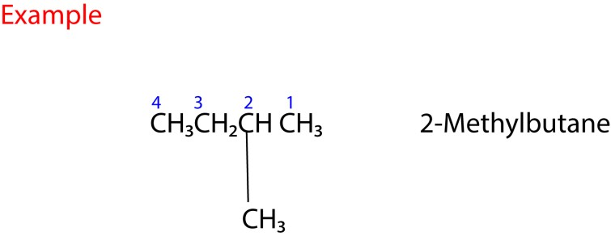
Note: there should not be space between the alkyl group radical and the main alkane e.g.
the correct name is 2-methylbutane and NOT 2-methyl butane

- If there more than one similar alkyl groups attached to the longest chain; use di, tri, tetra to indicate the number of such groups on the main chain.
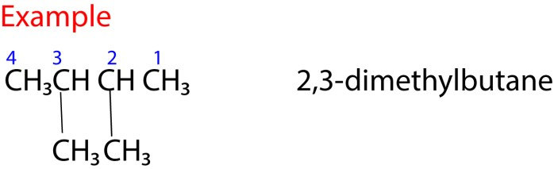
Note that
- This name implies that there is a methyl group attached to carbon in position 2 and another methyl group attached to carbon in position 3 of the butane molecule.
- When writing the name of organic compound, a coma (,) is placed between figures and a dash (-) between a figure and a letter.
- If different branches; name them alphabetically
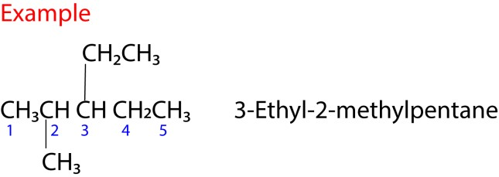
Note that
“E” for ethyl group comes before “M” for methyl group in the alphabets.
- If branching occurs at equal distance from either side of the main chain, choose a name that gives the least sum of combination of numbers.

Example

C

H

3

1

C

C

H

3

C

H

3

C

H

3

C

H

C

H

3

2

4

3

2,2,3-trimethylbutane AND NOT 2,3,3-triethylbutane

sum = 7 sum = 8
2,2,3-trimethylbutane is the correct name because it gives the least sum for the combination of numbers.

Trial 1
Name the following compounds
- CH₃CH₂CH₂CH₂CH₂CH₃ (b) CH₃CHCH₃CH₂CH₃
CH₃
CH₃
- CH₃CH₂CHCH₂CH₃ (d) CH₃CHCHCH₃

CH₃ CH₃ CH₃
(e) CH₃ C CH₃
CH₃

Solution
- CH3CH2CH2CH2CH2CH3 (b) CH3CHCH3CH2CH3 2-methylpentane

CH₃
Hexane
CH₃
- CH₃CH₂CHCH₂CH₃ (d) CH₃CHCHCH₃ 2,3-dimethylbutane

CH₃ CH₃
3-methylpentane
CH₃

(e) CH3 C CH3 2,2-dimethypropane
CH₃

Physical properties of alkane
- they are insoluble in water
- they are soluble in organic solvents
- they range from gases to liquids to waxy solids

Chemical properties
- They burn in air to produce carbon dioxide, water and heat. Due to production of heat they are used as fuel.
Example
CH₄ + 2O₂ → CO₂ + 2H₂O + heat
- Chlorination: they react with chlorine in presence of sunlight or u.v-light to produce chlorinated alkanes.
Example
CH₄ + Cl₂ may give CH₃Cl chloromethane
CH₂Cl₂ dichloromethane
CHCl₃ trichloromethane
CCl₄ tetrachloromethane

Mechanism
A mechanism is a step by step pathway followed by a reaction from the reactant to the products.
The following are steps followed in chlorination of methane
- Chlorine molecules dissociates into free radicals/ atoms with unpaired electron. Free radicals are indicated by a dot on the atom that possesses un paired electron

l

C

l

C

L
2
Cl

- Chlorine radical attacks methane to produce hydrogen chloride and a methyl radical.

H

C

H

C

l

C

H

H

H

H

H

+
HCl

Methyl radical
- Methyl radical reacts with a chlorine molecule to form chloromethane and a chlorine radical
H H

C

+

C

l

C

l

C

H

H

H

H

HCl +

Cl

Chloromethane

- Chlorine radical attacks a chloromethane to produce hydrogen chloride and a chloromethyl radical.

C

H

C

l

C

H

H

Cl

Cl

H

H

Chloromethyl radical

+
HCl

- Chloromethyl radical reacts with a chlorine molecule to form dichloromethane and a chlorine radical

C

+

C

l

C

l

C

H

H

H

H

Cl

Cl

Cl

Cl
+

Chloromethyl radical

dichloromethyl radical

- Chlorine radical attacks a dichloromethane to produce hydrogen chloride and a dichloromethyl radical.


l
+

C

H

C

l

C

C

l

Cl

Cl

Cl

H

H

HCl
+

Dichloromethane dichloromethyl radical

- Dichloromethyl radical reacts with a chlorine molecule to form trichloromethane and a chlorine radical

C

+

C

l

C

l

C

C

l

H

Cl

Cl

Cl

Cl

H + Cl

Dichloromethane trichloromethane

- Chlorine radical attacks a trichloromethane to produce hydrochloride and a trichloromethyl radical.


C

H

C

l

C

C

l

Cl

Cl

Cl

Cl

Cl

HCl
+

Trichloromethane Trichloromethyl radical
- Trichloromethyl radical reacts with a chlorine molecule to form tetrachloromethane and a chlorine radical

C

+

C

l

C

l

C

C

l

Cl

Cl

Cl

Cl

Cl

Cl

Cl
+

Trichloromethyl radical tetrachloromethane

Terminating steps
Meanwhile the radicals may combine to produce molecules. The reactions where radicals react to produce molecules is called terminating steps i.e., they eat up the free radicals and prevent the reaction from continuing.
Some of the terminating steps are:-
1. Chlorine radical + chlorine radical produces chlorine molecule
C l + C l Cl₂
- Methyl radical + methyl radical produces ethane
H₃C + CH₃ CH3CH3
- Methyl radical reacts with chlorine radical to form chloromethane and so on.

H₃C + Cl CH₃^{Cl}

Sources of alkanes
- Petroleum product
- Biogas
Biogas is produced by anaerobic decomposition of organic matter (such as cow dung, plant remains, and feces) in presence of water. The main component of biogas is methane.

Laboratory preparation
- By coupling reaction of alkylhalide in presence of sodium and dry ether. For instance a chloromethane molecule couples with a chloromethane molecule to form ethane Na/dry ether
2CH₃Cl CH₃CH₃

- By reduction of alkenes, e.g.
CH3CH  CH3CH2CH3

CH
2
H
2
/Ni
Propene propane

- Reduction of alkynes, e.g.
CH₃C CH  CH₃CH₂CH₃
H
2
/Pt
Propyne propane

- Reduction of alcohols, e.g.
CH3CH2OH CH3CH3
H
2
/Pt
Ethanol ethane 5. Reduction of carbonyl compound, e.g.
CH3CHO ^{H2/Ni} CH3CH3
Ethanal ethane

- By reduction of carboxylic acid, e.g.
CH3COOH CH3CH3
H
2
/Ni
Ethanoic acid ethane

- By cracking long alkane
Cracking is the breakdown of long chain hydrocarbons into short chain alkanes.
Cracking may be catalytic where a catalyst is used or thermal when heat is used.

Alkenes
These are hydrocarbons that caontain aa double bond
General formula is C_{n}H_{2n} where n ≥ 2
Examples are
Ethene | CH₂=CH₂
Propene | CH₃CH=CH₂
But-1-ene | CH₃CH₂CH=CH₂
But-2-ene | CH₃CH=CHCH₂
For branched alkene we number the carbon atoms from the side nearest the double bond
For example

4 3 2 1
CH₃CHCH CH₂ 3-methylbut-1-ene
CH3
Physical properties
They like those of alkane
- they are insoluble in water
- they are soluble in organic solvents
- they are solvents
- they range from gases to liquids to waxy solids

Chemical properties

1. Combustion
They burn in air to produce carbon dixide, water and heat. C₂H₄ (g) + 3O₂ (g) 2CO₂(g) + 2H₂O + heat
Because they produce heat they are used as fuel.

2. Reduction
They are reduced by hydrogen in presence of catalysts; nickel or platnum to alkenes Example
CH₂=CH₂ H₂/Ni CH₃CH₃

3. Hydration reaction
(i) Reaction of alkenes with KMnO₄ solution
Dilute alkaline KMnO₄ solution convert alkenes into compound called GLYCOLS (dihydroxyl alcohols)
Example


CH
2

CH
2

KMnO
4
/
-
OH CH
2

CH
2

OH

OH

cis
-
ethane
-
1
2
,
-
diol

Mechanism



H
2
CH

C
2

H
2
CH
C

2

C H
2

CH
2

O
Ö

Mn

O O
-

O
O

Mn

O O
-

OH

OH

Te reaction proceeds with decolorization of the solution and is used to test for unsturation

4. Electrophlic addition reactions
Alkenes react with electron deficient groups called electroples to form saturated compounds.

Definitions
Electrophilic addition reaction is a reaction where an electron deficient groups adds to unsaturated compound (alkenes or alkynes) to form saturated compounds.

Addition of halogens
Halogens add across a double bond to form dihalogeno compounds.The reaction is carried out in an innert solvent (like tetrachromethane)

Example 1
Propene reacts with bromine in presence of innert solvents (trachloromethane) to form 1,2dibromopropane



CH
3
CH

CH
2

Br
2
/CCl
4

CH
3
C

CH
2

H

Br

Br

Propene

1
,
2
-
dibromopropane

Mechanism


CH
3
C

CH

2

CH
3

CH
C
2

CH
3
C
CH

2

H

Br
Br

+

Br

:
Br
-

H

H

Br

Br

Example 2
2-methylpropene plus chlorine in presence of tetrachloromethane give 1,2-dichloro-2-methylpropane



CH
2

CCH
3

Cl
2
/CCl
4

CH
2

CCH
3

CH
3

2
-
methylpropene

1
,
2
-
dichloro
-
2
-
methylpropane

CH
3

Cl

Cl

Mechanism



H
2
CCH
C

3

H
2
C
CCH

3

H
2
CCH

C
3

Cl

Cl

CH
3

CH
3

CH
3

Cl

Cl

Cl

+

:
Cl
-

Example 3
Phenylethene plus bromine in presence of tetrachloromethane give 1,2-dibromophenylethane



CH
3
CH

CH
2

Br
2
/CCl
4

CH
3
CH

C
2

H

Br

Br

Phenylethene

1
,
2
-
dibromophenylethane

Mechanism


CH
3

C

CH

2

CH
3
C

CH
2

CH
3
C
CH

2

H

Br
Br

+

Br

Br
:
-

H

H

Br

Br

Example 4
2-methylpropene plus bromine in presence of tetrachloromethane gives 1, 2-dibromo-2-methylpropane

CH
2

CCH
3

Br
2
/CCl
4

CH
2

CCH
3

CH
3

2
-
methylpropene

1
,
2
-
dibromro
-
2
-
methylpropane

CH
3

Br

Br

Mechanism

H
2
CCH

C
3

H
2
CCH

C
3

H
2
CCH

C
3

Br

Br

CH
3

CH
3

CH
3

Br

Br

+

:
Br
-

B
r

1
2
,
-
dibromro
-
2
-
methylpropane

Reaction of alkenes with HX (X = Cl, Br, I)
The reaction is carried out by bubbling HX through alkenes. X of HX attaches its self to the carbon atom that carries the least number of hydrogen atoms while the hydrogen atom of HX to the carbon atom that carries the highest number of hydrogen atom of those carbon atoms that form the double bond. This emperical observation is called Markoncoff’ rule

Example 5
Propene plus hydrochloric acid gives 2-chloropropane

CH
3

CH
CH
2

HCl

CH
3

CH
C
2

H

H

Cl

Propene

2
-
chloropropane

Mechanism


CH
3
CH

C
2

CH
3
CH

C
2

CH
3
CH
C

2

H

H

Cl

+

H

:
Cl
-

H

H

H

Cl

2
-
chloropropane

Example 6
Phenylethene plus hydrogen bromide give 1-bromo-1-phenylethane



CH
3
CH

CH
2

HBr

CH
3
CH

C
2

H

H

Br

Phenylethene

1
-
bromo
-
1
-
phenylethane

Mechanism



CH
3
C
CH

2

CH
3
CH

C
2

CH
3
CH

C
2

H

Br

H

+

H

Br
:
-

H

H

H

Br

Trial 2

Complete and write a mechanism

CH
3

C

CH
2

CH
3

HCl

)
i
(

2
-
Phen
ylpropene

CH
3
CH

CCH
3

CH
3

(
ii
)

HBr

2
-
Methylbut
-
2
-
ene

Solution to trial 2

(i) 2-phenylpropene plus HCl gives 2-chloro-2-phenylpropane


CH
C

2

CH
3

HCl

CH
C
2

CH
3

H

Cl

2
-
Phenylpropene

2
-
chloro
-
2
-
Phenylpropane

Mechanism

C

CH
2

CH
3

CH

C
2

CH
3

CH
3

H

Cl

C
CH
2

H

Cl

+

H

:
Cl
-

(ii) 2-methylbut-2-ene plus HBr gives 2-bromo-2-methylbutane


Mechan
ism

CH
3
C

CCH
3

CH
3

HBr

2
-
Methylbut
-
2
-
ene

CH
3
CCH

C
3

CH
3

CH
3
C

CCH
3

CH
3

Br

H

H
Br

CH
3

CCH
C
3

CH
3

H

CH
3

C
CCH
3

CH
3

Br

H

+

:
Br
-

2
-
bromo
-
2
-
methylbutane

2
-
bromo
-
2
-
methylbutane

H

H

H

H

Reaction of alkenes with halogens in presence of water
The reaction is carried out by bubbling alkenes through aqueous halogens. OH group attaches its self to carbon atom that carries the least number of hydrogen atoms of the carbon atoms that form a double bond

Example 7
Reaction of propene with bromine in presence of wate gives 1-bromopropna-2-ol



CH
3

CH
CH
2

Br
2
/
H
2
O

CH
3
C
CH

2

H

Br

OH

Propene

1
-
bromopropan
-
2
-
ol

Mechanism


CH
3

CH

C
2

CH
3

CH
C
2

CH
3
CH

C
2

CH
3
CH

C
2

H

Br
Br

+

Br

:
OH
2

H

H

Br

OH
2

+

H

Br

OH

1
-
bromopropan
-
2
-
ol

-
H
+

Trial 3
Complete the following and write meachnaism (do not look at the answer before)


CH
3

CH

C
2

CH
3

Cl
2
/H
2
O

)
i
(

2
-
Phenylpropene

CH
3
C H

CCH
3

CH
3

)
(
ii

2
-
Methylbut
-
2
-
ene

Br
2
/H
2
O

Solution to trial 3
(i) 2-phenylpropene plus HCl gives 1-chloro-2-phenylpropan-2-ol


CH

C
2

CH
3

Cl
2
/
H
2
O

C
CH

2

CH
3

Cl

OH

2
-
Phenylpropene

1
-
chloro
-
2
-
Phenylpropan
-
2
-
ol

Mechanism


C

CH
2

CH
3

CH
C

2

CH
3

CH
3

H

CH
C

2

Cl

Cl

+
H

:
OH
2

OH
2

+
C

CH
2

CH
3

Cl

OH

1
-
chloro
-
2
-
Phenylpropan
-
2
-
ol

-
H
+

(ii) 2-methylbut-2-ene plus bromine in presence of water gives 3-bromo-2-methylbutan-2-ol
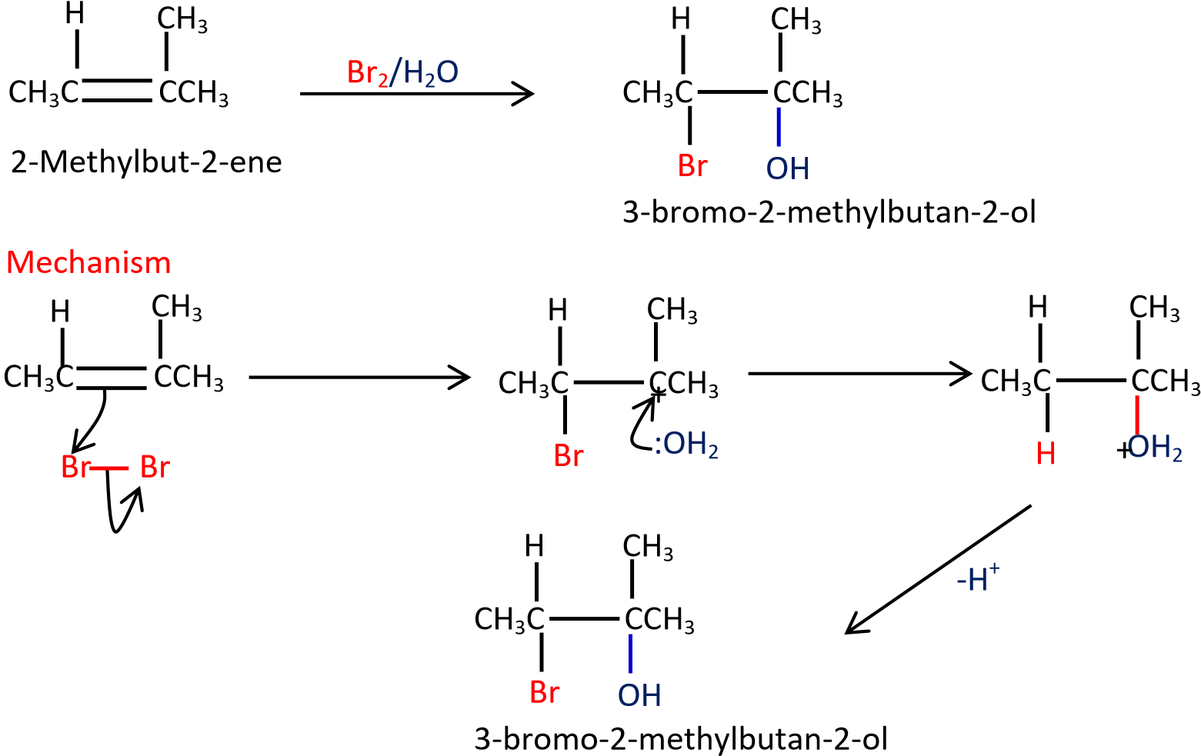

Trial 4
Complete and write a mechanism
CH₂ CHCH₃ Cl2/H2O

Propene

Solution
CH² CHCH3 Cl2/H2O CH CHCH₃
2

Propene Cl OH

MECHANISM

H ₂C CHCH₃ H₂C CHCH₃ ^{-H+} CHCH₃
C
l
+
H
O
:
H
2
C
C
l
H
H
2
O
C
H
C
H
3
C
H
2
C
l
C
l

+OH Cl2

Trial 5



d)
(
CH
(
3
)
2

C
CH
2

+
Cl
2

CH
(
3
)
2

C

CH
2

)
(4
marks

Mechanism

CH
(
3
)
2

C
CH
2

OH

Cl

Cl

Cl

CH
(
3
)
2
C

CH
2

Cl

+

OH
:
2

(
CH
3
)
2
C

CH
2

OH
2

Cl

+

CH
(
3
)
2

C
CH
2

OH

Cl

-
H
+

H
2
O

(d) Reaction of alkene with water.
The reaction is catalysed by an acid (sulphuric acid or phosphoric acid). Alcohols are produced Example 8
Ethene reacts with acidified water to produce ethanol.
CH2 CH2 H2O/H+ CH3CH2
Ethene OH
Ethanol

MECHANISM
C
H
2
H
+
-H⁺
C
H
2
+
H
O
:
H
3
C
C
H
2
H
2
O
+
C
H
3
H2CH₃CCH₂
OH
2

Example 9
Propene reacts with dilute sulphuric acid to form propan-2-ol
CH3CH CH2 dil H2SO4 CH3CH CH3
Propene
OH
Propan-2-ol

MECHANISM

H H

H
C
H
2
H
C
H
3
+
H
2
O
:
C
H
3
H
O
+
-
H
+
C
H
3
C
C
H
3
C
C
H
3
C
C
H
3
O
S
O
3
H
CH CH₃
2 OH Propan-2-ol

Trial 5
Complete the following equations and suggest mechanisms
C
C
H
2
d
i
l

H
3
P
O
4
(
i
)
(
i
i
)
C
H
3
d
i
l

H
3
P
O
4
C
H
3

Solution to trial 5
CH₃ CH₃
CH²
(i)
H
C
C
H
2
d
i
l

H
3
P
O
4
C
O
H
2-Phenylpropan-2-ol 2-Phenylpropene
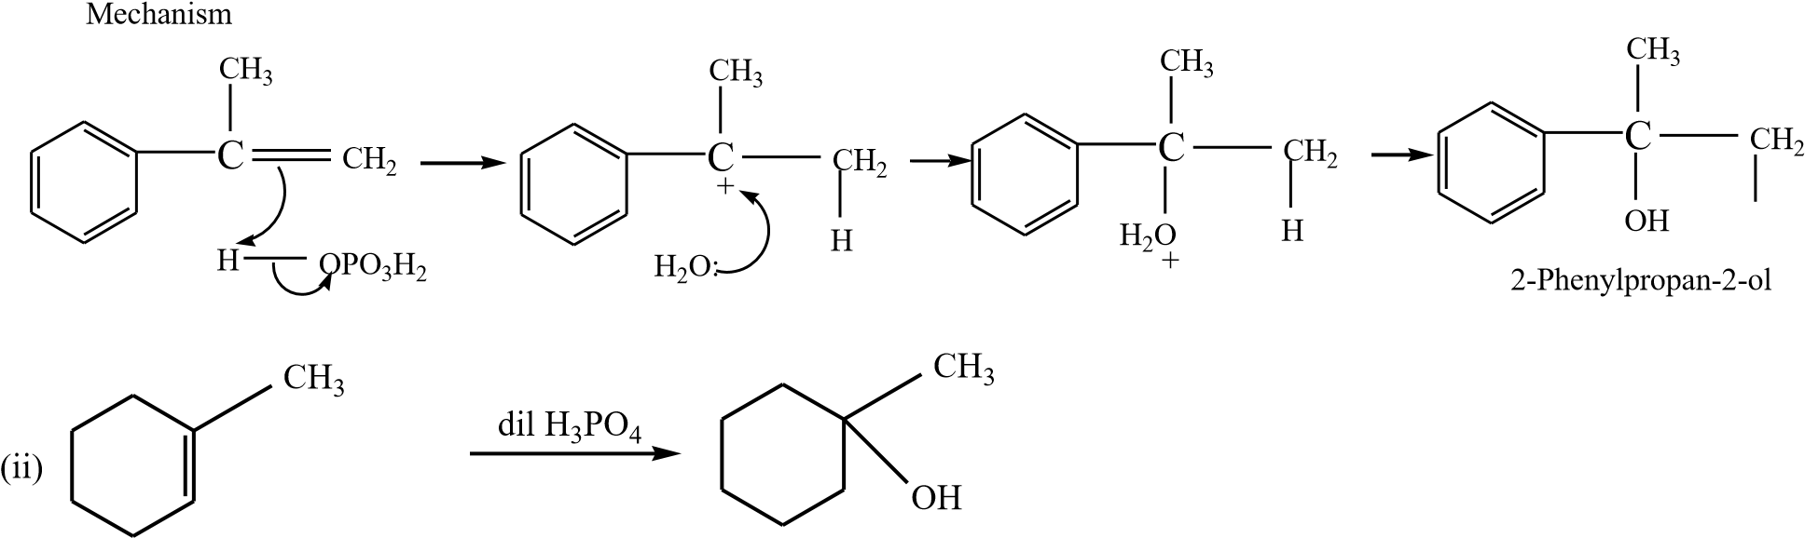H
1- Methylcyclohexene 1-methylcyclohexanol
Mechanism +
H
O
P
O
3
H
2
H
+
:
O
H
2
C
H
3
C
H
3
C
H
3
H
2
O
O
H
C
H
3
1
-
m
e
t
h
y
l
c
y
c
l
o
h
e
x
a
n
o
l
H
-
H
+

NB. The charges must be accounted for at every stage

(e) Addition of hydrogen bromide in presence of a peroxide
In presence of a peroxide, alkenes react with HBr by free radial mechanisms; but in this case hydrogen atom goes to a carbon atom that carry the least number of a hydrogen atoms of those that form a double bond otherwise the bromine atom goes to a carbon with the highest number of hydrogen atoms.

Example 10
HBr/Peroxide
Propene  Instead of  CH₃CH=CH₂  Propene  Mechanism | HBr  HBr/Peroxide | H Br  1-bromopropane  CH₃CH CH₂  Br H  2-bromopropane
(ii) CH CH=CH |  | CH CH
CH₃CH=CH₂ CH₃CH CH₂

₃ ₂ ₃ CH₂
H Br
1-bromopropane
ROthe dot on the oxygen atom indicates
O
R
2
R
O
that the oxygen atom has one unpaired electron Then

RO + HBr ROH + Br
H H
CH₃C CH₂ + Br CH₃C CH₂Br
H H
CH₃C CH₂Br + HBr CH₃C CH₂Br + Br
H 1-bromopropane

Trial 6
Complete and write a mechanism (it advisable you attempt these questions and mark yourself)
HBr/peroxide
(i) CH₃CH₂CH CH₂
CH₃
HBr/peroxide (ii) CH₂C CH₃

Solutions to trial 6
H
HBr/peroxide
(i) CH₃CH₂CH CH₂ (i) CH₃CH₂CH CH₂Br
ROthe dot on the oxygen atom indicates
O
R
2
R
O
that the oxygen atom has one unpaired electron Then

RO + HBr ROH + Br

H H
CH₃CH₂C CH₂ + Br CH₃CH₂C CH₂Br
H H
CH₃CH₂C CH₂Br + HBr CH₃CH₂C CH₂Br + B r
H

HBr/peroxide
R
O
O
R
2
R
O
t
h
e

d
o
t

o
n

t
h
e

o
x
y
g
e
n

a
t
o
m

i
n
d
i
c
a
t
e
s
t
h
a
t

t
h
e

o
x
y
g
e
n

a
t
o
m

h
a
s

o
n
e

u
n
p
a
i
r
e
d
(
i
i
)

C
H
2
C

C
H
3
C
H
3
C

C
H
3
C
H
3
C
H
2
H
B
r
electron Then

RO + HBr ROH + Br
CH₃ CH₃
CH₂C CH₃ + Br C CH₃
C
H
2
CH₃ Br CH₃
C CH₃ + HBr C CH₃ + Br
C
H
2
C
H
2
Br Br H

(f) Ozonolysis (reaction of ozone with alkenes)
Ozone reacts with alkene to form unstable ozonide that is reduced by zinc in presence of hydrochloric acid to form carbonyl compounds.

Example 11
OH
1. O₃, -78⁰C
C
CH3CHCH₂ 2. Zn/HCl CH₃C+ O
H
H
From the products of ozonolysis, it is possible to tell the position of the double bond in the compound that was ozonolyzed because ozonolysis breaks a compound at the double bond.

Example 12
Write the structure of an alkene which on ozonolysis gave
- Propanal (CH₃CH₂CHO) and methanol (HCHO)
By removing the oxygen atoms from each compound create a double bond and hence the compound.
H Remove
O
O
CH3CH2C CH2 CH3CH2CH CH2
Propanal Methanal But-1-ene
- One product ethanal
CHCH₃ CH₃CH CHCH₃
C
H
3
C
O
E
t
h
a
n
a
l
O
R
e
m
o
v
e
H
Ethanal But-2-ene

Trial 7
An alkene X has molecular formula C₄H₈
- Write and name all structural formulae of compound X.
- On ozonolysis X gave propanone (CH₃COCH₃) and methanal (HCHO). Identify X.
Solution
(a)
CH₃CH₂CH | CH₂ | But-1-ene
CH₃CH | CHCH₃ | But-2-ene
CH₃C CH₃ | CH₂ | 2-Methylpropene
(b) By removing oxygen atoms from the products of ozonolysis, the position of a double bond is created.
CH₂ CH₃C CH₂
C
H
3
C
O
P
t
o
p
a
n
o
n
e
O
R
e
m
o
v
e
C
H
3
Methanal CH₃
2-Methylpropene Therefore X is 2-methylpropene.

Polymerization
This is the is the joining of very many small molecules called monomers to form big molecules called polymers
In presence of a catalyst, (acid) alkenes polymerize to form polyalkenes.
For example ethene plus a catalyst gives polyethene
CH₂CH₂
catalyst
nCH₂=CH₂ * *
n
Ethene Polyethene

(ii) Propene polymerize to form polypropene

CH₃
n
c
a
t
a
l
y
s
t
*
nCH₃CH=CH₂CH CH₂*
Propene Polypropene
- Vinyl chloride polymerize to form polyvinylchloride (PVC)
Cl
nCH₂ *
c
a
t
a
l
y
s
t
C
H
2
C
H
*
n
C
H
C
l
Vinyl chloride
Polyvinyl chloride
- Styrene polymerizes to form polystyrene.
c
a
t
a
l
y
s
t
C
H
C
H
2
*
*
n
C
H
2
C
H
n
S
t
y
r
e
n
e
P
o
l
y
s
t
y
r
e
n
e

Note that when given a polymer without a double bond; then the monomer contains a single double bond.

Trial 8
Write the structure and the names of monomer for the following polymers
C
H
C
H
2
C
H
C
H
2
C
H
C
H
2
C
H
C
H
2
*
*
C
H
3
C
H
3
C
H
3
C
H
3
(
i
)
n

*
C
H
2
C
C
H
3
C
O
O
C
H
3
C
H
2
C
C
H
3
C
O
O
C
H
3
C
H
2
C
C
H
3
C
O
O
C
H
3
n
(
i
i
)
*

C
N
C
N
C
N
C
N
(iii) **
C
H
2
C
H
C
H
2
C
H
C
H
2
C
H
C
H
2
C
H
n

*
C
H
2
C
O
O
C
C
H
3
C
H
2
C
C
H
2
C
n
(
i
v
)
*
O
O
C
C
H
3
O
O
C
C
H
3
H
H
H

Solutions
Propene
C
H
C
H
2
C
H
C
H
2
C
H
C
H
2
C
H
C
H
2
*
*
(
i
)
n
C
H
3
C
H
=
C
H
2

P
o
l
y
p
r
o
p
e
n
e
C
H
3
C
H
3
C
H
3
C
H
3
*
C
H
2
C
C
O
O
C
H
3
C
H
2
C
C
H
2
C
(
i
i
)
C
H
2
C
C
O
O
C
H
C
H
3
C
H
3
3
CH CH₃
*
³ COOCH₃ n COOCH3
methylmethacrylate polymethylmethacrylate
CN CN CN CN
(iii) ** C AHc2r=yCloHnCitrNid e
C
H
2
C
H
C
H
2
C
H
C
H
2
C
H
C
H
2
C
H
n
Polyacrylonitride
*
C
H
2
C
O
O
C
C
H
3
C
H
2
C
C
H
2
C
n
(
i
v
)
*
O
O
C
C
H
3
O
O
C
C
H
3
H
H
H
C
H
2
C
O
O
C
C
H
3
H
vinylacetate
Polyvinylacetate
Uses of polyalkenes
- packing materials
- water pipes - insulators
Alkenes undergo a type of polymerization called addition polymerization because monomers add to form a polymer without loss of any atom.
Polyalkenes are also called thermoplastics because they soften on heating and can be remolded.

Polymerization of dienes
Alkenes with conjugated double bond undergo polymerization to form polyalkenes with double bonds
Example
CH₂CH=CHCH₂ polybutadiene
- nCH₂=CHCH=CH₃ * * But-1,3-diene n

- nCH₂=C CH=CH₂ * CH₂C=CHCH₂*

CH3 CH3 n
methylbut-1.3-diene
Reaction with carbon monoxide

Co₂(CO)₈
RCH=CH₂ + CO + H₂ R CH₂CH₂CHO
Heat/high pressure
Example

(a) CH₂ = CH₂ CO, H₂ /Co₂(CO)₈ CH₃CH₂CHO Propanal
Heat/high pressure

Preparation of alkenes
1. From alcohols
Alkenes are produced by dehydration of alcohols by hot sulphuric or phosphoric acid. Alcohols are organic compounds that contain hydroxyl group (-OH). The mechanism depends on the class of alcohol.

Classification of alcohols,
They are three classes of alcohols according to the number of alkyl groups attached to a carbon atom that carry -OH group.
- Primary alcohols have one alkyl group on the carbon atom that carry OH group Example 12
H H H H
  - OH H C OH
C
C
C
C
H
H H | H H H
Ethanol | Propan-1-ol

- Secondary alcohols have two alkyl groups attached to a carbon atom that carry OH group Example 13
H H H H H H H
  - C H H CH
C
C
C
C
C
H OH H  Butan-2-ol | H | H OH H  Propan-2-ol
- Tertiary alcohols
Tertiary alcohols have three alkylgroups attached to the carbon atoms that carry OH group Examples
H CH₃ H H CH₃ H
  - C H H
C
C
C
C
C
H OH H H OH H
2-methylbutan-2-ol 2-phenylpropan-2-ol

Mechanism
Depends on the class of alcohol.
(a) Primary alcohol: undergo a mechanism called elimination bimolecular(E2). It is an elimination reaction because water molecule is removed from the alcohol. It bimolecular because the slow step involves two species.

Example 14

CEHth3CanHo2lOH Choenact .(H128S0O0C4) CEHth2e=nCeH2

Mechanism
Example 15
CH₃CH₂CH₂OH  Propan-1-ol | Conc.H₃PO₄  heat | CH₃CH=CH₂  Propene
H H
C
H
3
C
H
2
O
H
C
H
2
=
C
H
2
H
O
S
O
3
H
H
C
C
O
H
2
H
H
O
S
O
3
H

Mechanism
C
H
3
C
H
2
=
C
H
2
H
O
P
O
3
H
2
C
O
H
2
H
H
H
H
O
P
O
3
H
2
C
H
3
C
H
2
C
H
2
O
H
C
H
3
C

Trial 9
Complete and write a mechanism
CH2CH2OH Conc.H2SO4
heat

Solution
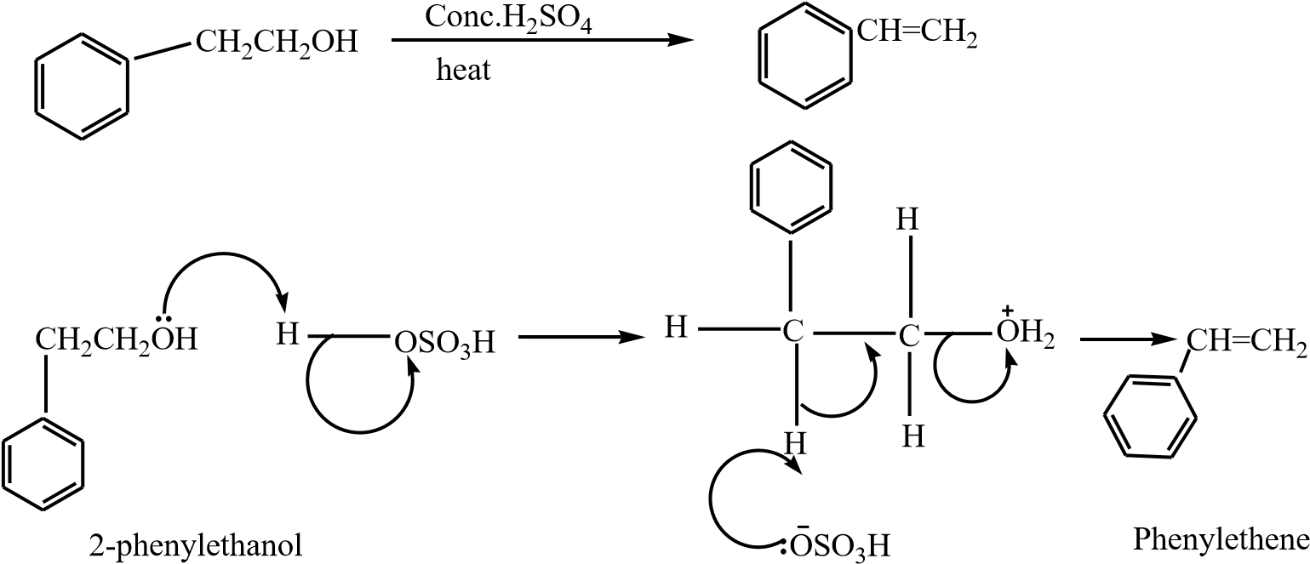

- Secondary alcohols undergo the same mechanism as primary alcohol or that of tertiary alcohol
- Tertiary alcohol undergoes a mechanism called E1 or elimination unimolecular because a water molecule is eliminated and the slowest step involve one molecule only.

Example 16
H
3
C
C
C
H
3
C
H
3
O
H
C
o
n
c
.

H
2
S
O
4
h
e
a
t
H
2
C
C
C
H
3
C
H
3
2
-
m
e
t
h
y
l
p
r
o
p
a
n
-
2
-
o
l
2
-
m
e
t
h
y
l
p
r
o
p
e
n
e

Mechanism
H
3
C
C
C
H
2
C
H
3
O
H
H
2
C
C
C
H
3
C
H
3
H
O
S
O
3
H
O
H
2
O
S
O
3
H
H
3
C
C
C
H
3
C
H
3
H
3
C
C
C
C
H
3
H
H
H
-
H
+

Trial 10
Complete and write a mechanism CH₃
C
C
H
3
C
o
n
c
.

H
3
P
O
4
h
e
a
t
OH

Solution

CH CH₃
C
C
H
3
3
C
o
n
c
.

H
3
P
O
4
h
e
a
t
C
CH₂
OH

Mechanism
C
C
H
2
C
H
3
O
H
C
C
H
3
H
O
S
O
3
H
O
H
2
O
S
O
3
H
C
C
H
3
C
H
3
C
C
C
H
3
H
H
H
-
H
+
C
H
2

Preparation of alkenes from alkylhalide (R-X where R is alkyl group and X is Cl, Br or I)
The mechanism depends on the class of alkylhalide
Classification of alkyl halide
They are three classes of alkylhalide according to the number of alkyl groups attached to a carbon atom that carry a halide
(a) Primary alkylhalide have one alkyl group on the carbon atom that carries a halide.

Examples 18
H H H H
H Cl H C Br
C
C
C
C
H
H H | H H H
Chloroethane | 1-Bromopropane

(b) Secondary alkylhalide have two alkyl groups attached to a carbon atom that carry halogen atom

Examples19
H H H H H H
H C H H CH
C
C
C
C
H Br H  2-Bromopropane | H Cl H  2-chlorobutane

(c) Tertiary alkylhalide
Tertiary alkylhalide have three alkylgroups attached to the carbon atoms that carry OH group

Example 20
H Br H  2-bromo-2-methylpropane | H Cl H H  2-chloro-2-methylbutane
H CH H_{H} CH H H
C
3
C
C
3
C
H C H H C H
C

Mechanism
Depend on the class of alcohol.
(a) Primary alkyl halide: undergo a mechanism called elimination bimolecular(E2). It is an elimination reaction because HX is removed from the alkylhalide. It bimolecular because the slow step involves two species.

Example 21
ethanol/KOH CH2=CH2
CH3CH2Cl
Chloroethane ^{reflux} Ethene

Mechanism

Ethanol  Then | H | H
CH₃CH₂OH + OH CH₃CH₂O + H₂O
C
H
2
=
C
H
2
H
C
C
H
H
C
l
C
H
3
C
H
2
O
Example 22
CH₃CH₂CH₂Br  1-Bbromopropane | CH₃CH₂OH/OH  heat | CH₃CH=CH₂  Propene

Mechanism

CH₃CH₂OH + OH CH₃CH₂O + H₂O Ethanol
Then H H
C
H
3
C
H
=
C
H
2
H
3
C
C
C
H
H
B
r
C
H
3
C
H
2
O
s
l
o
w

Trial 10
Complete and write a mechanism
EtO- / EtOH
CH₂CH₂Cl  Solution | Reflux
Mechanism
H | H
CH₂CH₂Cl CH=CH₂
C
C
H
H
P
h
e
n
y
l
e
t
h
e
n
e
C
l
C
H
=
C
H
2
E
t
O

R
e
f
l
u
x
E
t
O
-
/
E
t
O
H

- Secondary alkyl halides undergo the same mechanism as primary alcohol or that of tertiary alcohol
- Tertiary alkyl halides undergo a mechanism called E1 or elimination uni-molecular because a water molecule is eliminated and the slowest step involve one molecule only. Example 23
H
3
C
C
C
H
3
C
H
3
I
C
H
3
O
/
C
H
3
O
H
h
e
a
t
H
2
C
C
C
H
3
C
H
3
2
-
I
o
d
o
-
2
-
m
e
t
h
y
l
p
r
o
p
a
n
e
2
-
m
e
t
h
y
l
p
r
o
p
e
n
e

Mechanism
H
2
C
C
C
H
3
C
H
3
I
H
3
C
C
C
H
3
C
H
3
H
3
C
C
C
C
H
3
H
H
H
C
H
3
O

Trial 11
Complete and write a mechanism
C
C
H
3
C
H
3
C
l
E
t
O
/
E
t
O
H
h
e
a
t

Solution
CH₂
C
C
H
3
C
C
H
3
C
H
3
E
t
O
/
E
t
O
H
h
e
a
t
Cl

Mechanism
C
l
C
C
H
3
C
H
3
C
C
C
H
3
H
H
H
C
C
H
2
C
H
3
E
t
O

Alkynes
General formula C_{n}H_{2n-2} where n≥2
They contain a triple bond
Examples
HC CH | Ethyne
CH₃C CH | Propyne
CH₃CH₂C CH | But-1-yne
CH₃C CCH₃ | But-2-yne

Preparation
1. From vicinal dihalides.
Vicinal dihalides are halides with two halogen atoms on adjacent carbon atoms
The reaction is carried out by refluxing vicinal dihalides with a mixture of an alcohol with its sodium or potassium salt.

Example 24
- Preparation of ethyne from 1,2-dibromoethane


o

CH
2
CH
2

EtO
-
/EtOH HC

CH

Br Br

Mechanism

Br Br Br

H

C

C

H
C
C

H H

C

H H

C

H H H

:
Ō
Et :
Ō
Et

- Preparation of but-2-yne from 2,3-dibromobutane


M
echa
n
i
s
m

B
r

B
r

B
r

C
H
3
C
H

CC
H
3

H

C
H
3
C

C
C
H
3

H

C
H
3
C

CC
H
3

Et
Ō:

2
.

P
rep
a
rat
i
o
n

o
f ethyne
from

car
b
o
n

CH
3
C

CCH
3

CH
3
C

CCH
3

H

Br

Br

H

3
2
,
-
dibromobutane

but
-
2
-
yne

Ethanol/
-
OH

reflux

EtO:

Ca (s) + 2C(s) heat CaC2 (s)

h
e
a
t

or CaO (s) + 3C (s) CaC₂ (s) + CO (g)

CaC₂ (s) + 2H₂O ^{HC} CH + Ca(OH)₂

3. Preparation of long chain alkyne from ethyne

HC CH a/li i a ia HC C-_{Na}+
Then
RX + HC C⁻Na⁺ HC CR

Example 25
CH3CH2Cl + HC C-Na+ HC CCH2CH3
Mechanism


H

CH
3

C
H

Cl

H
C

C
:

CH
3
CH
2

C
C
H

Trial 12
Synthesize

(a) HC CH from CH₃CH₂OH
P a g e | 39

(b) CH₃C CH from CH₃CH₂Cl

Questions involving synthesis requires a student to write a series of reactions including correct conditions; leading the formation of products from the reactant(s). Most of the times more than one equation is required because reactions of organic compounds are specific that we may need to convert the reactants into intermediate compounds before a product can be obtained.
Note that the synthesis is only correct when all the steps including the conditions are correct.
For instance, before baking bread, wheat flour is first convert to dough. Usually think of the intermediates to enable you complete a synthesis equation.

Solution

- CH₃CH₂OH conc. H₂SO₄ H₂C CH₂ Br2 / CCl4 _{H C CH} EtŌ / EtOH HC CH heat

2
2
h
ea
t

Br Br



- CH₃CH₂Cl EtO / EtOH _{H2C} EtŌ / EtOH HC CH heat
CH
2

B
r
2

/

C
Cl
4

H
2
C

C
H
2

h
ea
t

Br

B
r

+

CH
3
Cl

CH
3
C

CH

then

HC CH Na/liq. NH₃ HC CNa

Physical properties of alkynes

- They range from gases to liquids to solids
- They are insoluble in water but soluble in organic solvents

Chemical properties of alkynes

1. They burn in oxygen to give carbon dioxide, water and heat.
Example
2C2H4 + 5O2 4CO2 + 2H2O ₊ h_{eat}
They are used as fuel because they produce heat

2. Reduction
Depending on conditions, alkyne may be reduced to alkenes or alkanes

P a g e | 40

Example 27

C
H
3

CH

CH
2

C
H
3
C
H
2
C
H
3

CH
3
C

CH

.P a g e | 41

Note that reduction of alkyne to alkene has synthetic value because alkenes are more reactive than alkanes.

Example 28
Synthesize
CH3CH2CH2Br from CH 3C CH

Solution


C H Br CH₃C CH LiAlH₄/dry ether CH₃C CH₂ HBr/peroxide _{CH3CH2CH2Br}

Note that the first part of the synthesis involves reduction alkynes to alkene.

3. Addition reactions
Alkynes undergo addition reactions like alkenes except that the addition occurs twice. (a) Addition of HX (X= Cl, Br, and I Example 29
HCl

CH₃C CH CH₃CCl₂CH₃ 2,2,-dichloropropane

Mechanism


then

CH
3

C
CH

Cl
H

CH
3
C
CH

2

Cl
:
-

+

CH
3
C

CH
2

Cl

CH
3

CH
C
2

Cl

Cl

H

CH
3

C
CH
3

:
Cl
-

+

Cl

CH
3
C

CH
3

Cl

Cl

(b) Addition of halogens
The halogen is diluted with carbon tetrachloromethane (to prevent explosion)

Example 30


CH₃C CH ^{Cl2/CCl4} CH₃CCl₂CHCl₂ 1,1,2,2-tetrachloropropane

Mechanism


CH
3
C
CH

Cl
Cl

CH
3
C

CH

:
Cl
-

+

CH
3
CH

C

Cl

Cl

Cl

P a g e | 42

then

CH
3
CH

C

Cl

CH
3
C

CH

:
Cl
-

+

Cl

CH
3

CH
C
2

Cl

Cl

Cl

Cl

Cl

Cl

Cl

Cl

Cl

Trial 13
Complete and write a mechanism


CH
3
CH
2
C

CH

Br
2
/CCl
4

CH
3
CH
2
C

CH 1,1,2,2
-
tetrabromobutane

Br

Br

Br
Br

Mechanism


then

CH
3
CH
2
C

CH

CH
3
CH
2
C

CH

CH
3
CH
2
C

CH

Br
Br

:
Br
-

+

Br

Br

Br

CH
3
CH
2
C

CH

Br

Br

Br
Br

CH
3
CH
2
C

CH

:
Br
-

+

Br

Br

Br

CH
3
CH
2
C

C
H

Br

Br

Br

Br

(c) Addition of water.
The reaction is catalyzed by mercury (II) sulphate and dilute sulphuric acid. Carbonyl compounds are formed.

P a g e | 43

Example 31


H
C

CH

CH
3
CHO

H
g
S
O
4
,

d
i
l

Mechanism

H
C

CH

H
+

H
C

CH
2

:
OH
2

+

H
C

CH
2

H
C

CH
2

OH
2

O

H

+

H
C

CH
2

O H

Rearrangement

-
H
+

P a g e | 44

Complete and write a mechanism

CH₃CH₂C CH HgSO₄, dil


Solution

Mechanism

CH
3
CH
2
C

CH

H
g
S
O
4
,

d
i
l

CH
3
CH
2
C

CH
3

O

CH
3
CH
2
C

CH

CH
3
CH
2
C

CH

CH
3
CH
2
C

CH

CH
3
CH
2
C

CH

CH
3
CH
2
C

CH

O H

Rearrangement

O

H

OH
2

+

OH
:
2

+

H
+

-
H
+

(d) Reaction of terminal alkyne
Alkynes with a triple bond at the end of the chain react with ammoniacal silver nitrate or ammoniacal copper I chloride to form white precipitate or red precipitate respectively.


Exa
m
p
l
e

CH
3
CH
2
C

CH

CH
3
CH
2
C

C
Ag

White ppt.

Ag
+
/NH
3
(
aq
)

P a g e | 45

This reaction is used to distinguish alkynes with a triple bond at the end from those with a triple bond in the middle of the chain.

Exercise
Name one reagent that can be used to distinguish between the following pairs compounds. In each case state what will be observed when the reagent is treated with each of the compound of the pair.

- CH₃CH₂C CH and CH₃C CCH₃

- C CCH₃ and ^{CH}2^{C CH}

Reagent: ammoniacal silver nitrate

Observation
(a) CH₃CH₂C CH white precipitate

CH₃C CCH₃ no observable change

C CCH3 no observable change
(
b)

CH2C CH white precipitate

Revision questions

1. 10cm³ of a hydrocarbon X was exploded with 70 cm³ of Oxygen and cooled, the final volume was 55cm³. The volume of the mixture reduced to 15cm³ when shaken with concentrated potassium hydroxide solution.
(a) Determine the molecular formula of X. (b) Write and name all isomers of X.
- X formed a red precipitate with ammonial copper 1 chloride,
  - Identify X.
  - Write equations and suggest mechanism for the reaction between X and acidified water, hydrogen in presence of palladium catalyst and hydrogen peroxide.
- Write equations and conditions to show how X can be prepared from a named
  - Alcohol

